**SAP BW/BO Exercise**

**Exercise: Twitter Data Load into SAP HANA**

**Student Name: Nupur Ray Student Id: nxr163130**

**Date: 10/27/2016**

**Note: You must use the following conventions to name objects/systems created in this exercise.**

**Replace SM with A - for Fall semester**

**B - for Spring semester**

**C - for Summer semester**

**Replace YY with the last 2 digits of the current year.**

**Replace XXX with your SAP ID.**

**Objective**

Get familiar with the Twitter API and data load processes.

Every day, Global Bike Inc. produces thousands of bikes. Currently, the Shop Floor workers have to walk to the working stations, which are fixed to a certain place, in order to scan their products and to confirm that a new bike was completed. This is not only a waste of time which costs a lot of money, but also an exhausting part of the workers’ daily routine, which can make up to several kilometers a day just to confirm their charges. To counteract these vice president (Operations) engages production planner to do some research about various mobile devices as an alternative to the fixed working stations. Production planner is really enthusiastic about this idea and being a passionate Twitter user, he decides to do some analysis on Twitter data first, to get to know the opinions of users about the new iPad Pro and the Surface Pro 4. At lunch he tells his systems & database administrator about his ideas. Database administrator is always up to date on the newest technologies and suggests production planner to use GBI’s SAP HANA system for analyzing the data, as there is a brand new functionality for loading Twitter Data into the database.

**1) Create an App for your Twitter Account**

To load the data via the Twitter API you need to register an app. For this task you need a Twitter account. After creating an app, we will create access tokens to access the app.

Go to <https://apps.twitter.com/> and logon with your twitter account. Click on Create New App.

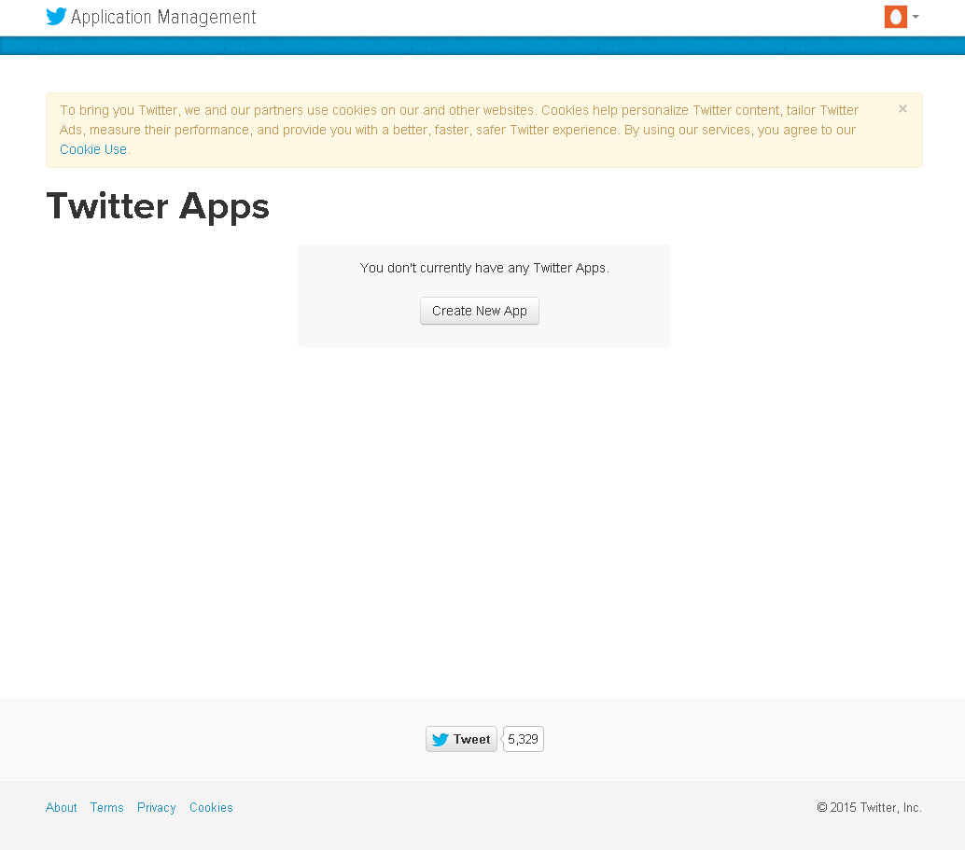

Enter a name (e.g. “GBI_###_Load”), a description (e.g. “GBI_### Twitter Data Load”) and a website (e.g. “http://www.sap-ucc.com”). Replace ### with your student id. Read the Developer Agreement and accept it by checking the box “Yes, I agree”.

Click on **Create your Twitter application**.

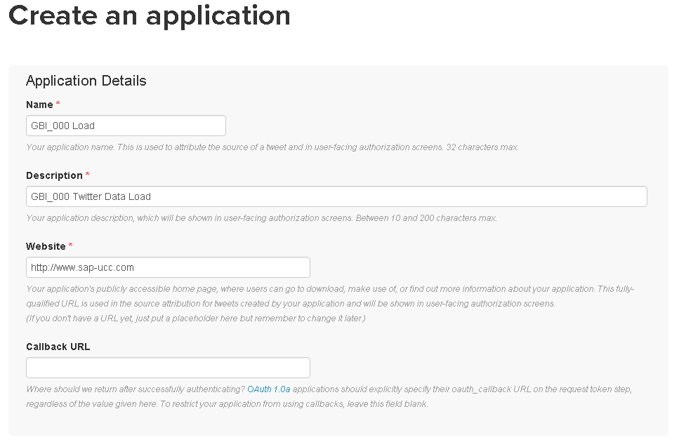

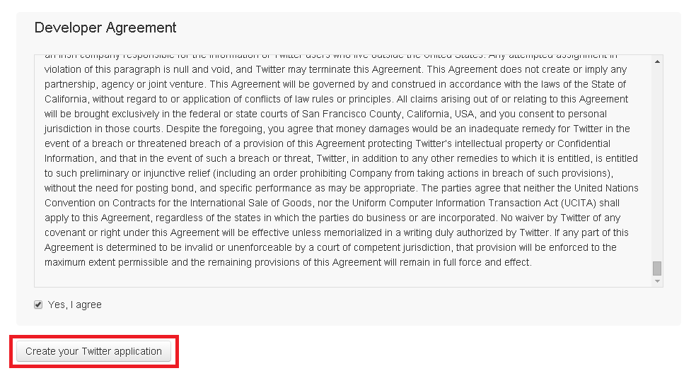

You will get a confirmation that your application has been created and the details of your app will appear.

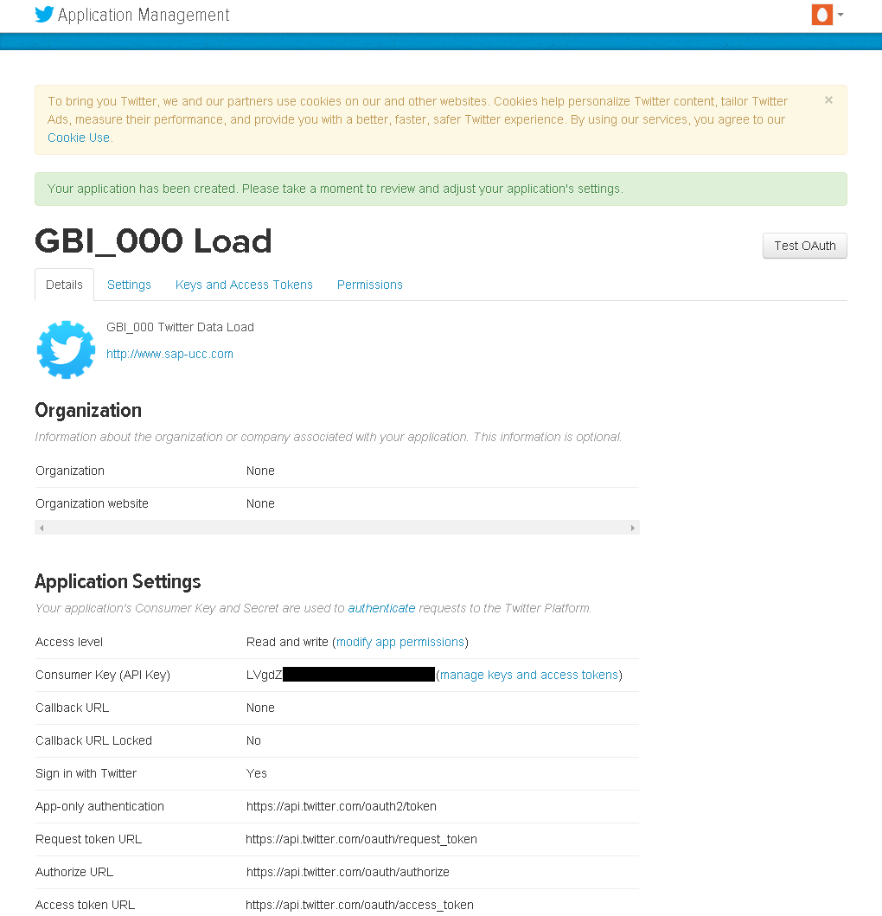

**Paste your screenshot here.**

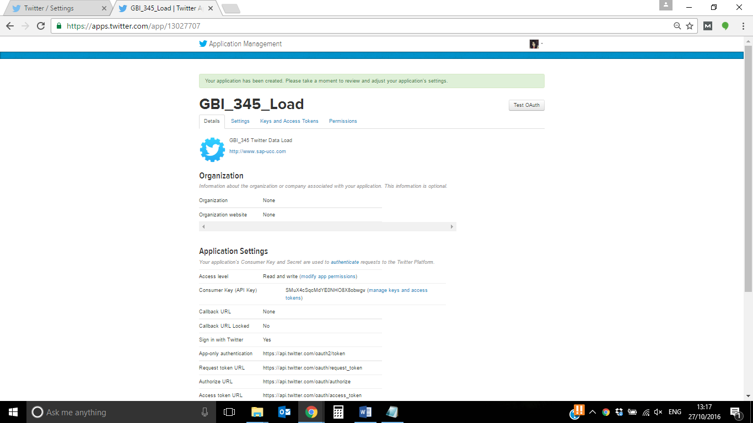

Go to tab “Keys and Access Tokens” to create the Access Tokens for your app.

You can see that a Consumer Key, also known as API Key, and a Consumer Secret, also known as API Secret, have already been created. For accessing Twitter data via the Twitter Adapter you also need an Access Token and Access Key.

To create those scroll to the bottom of the page and click on **Create my access token**.

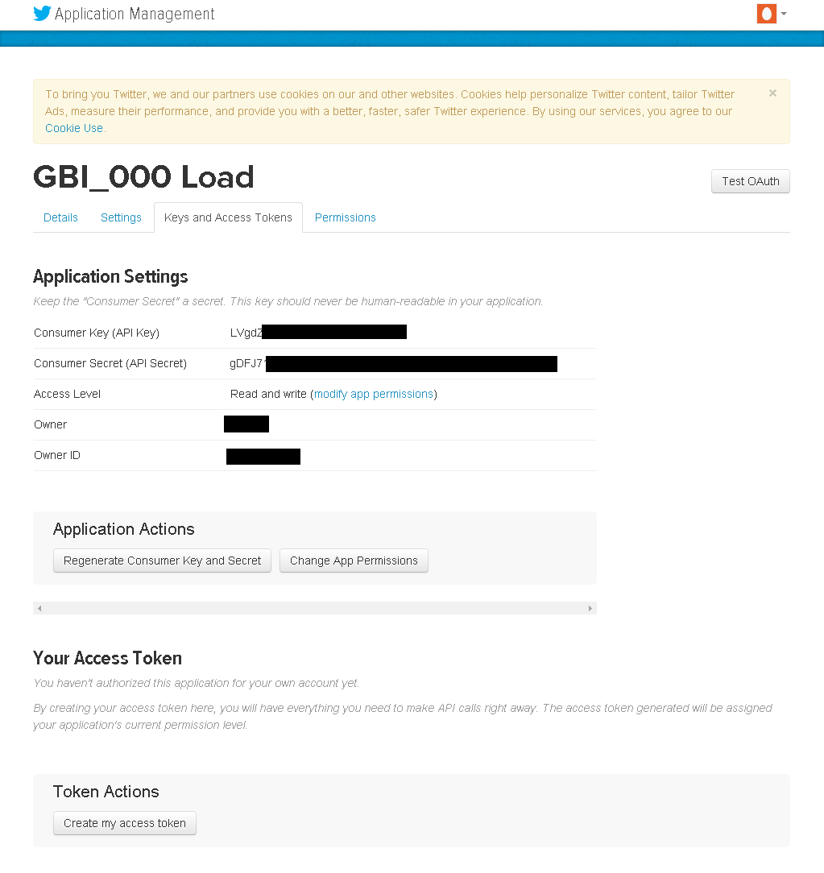

You will get a confirmation that the access tokens have been created.

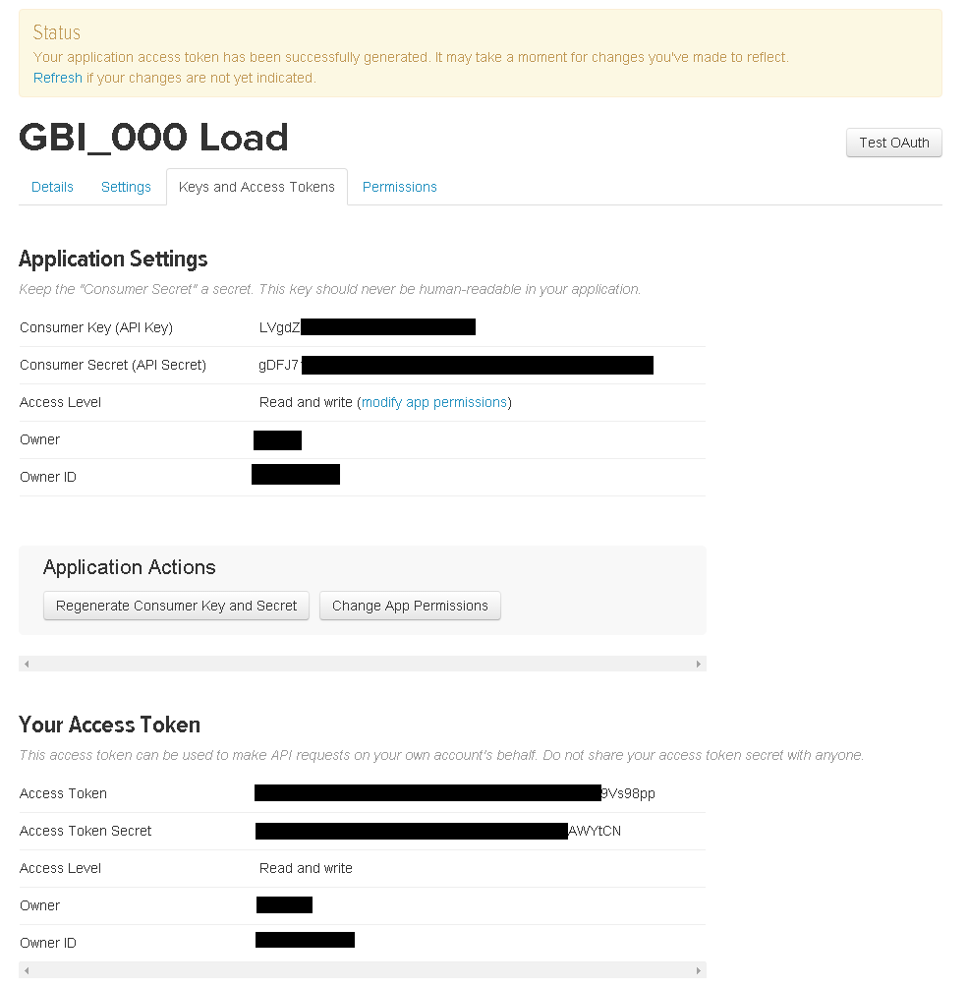

**Paste your screenshot here.**

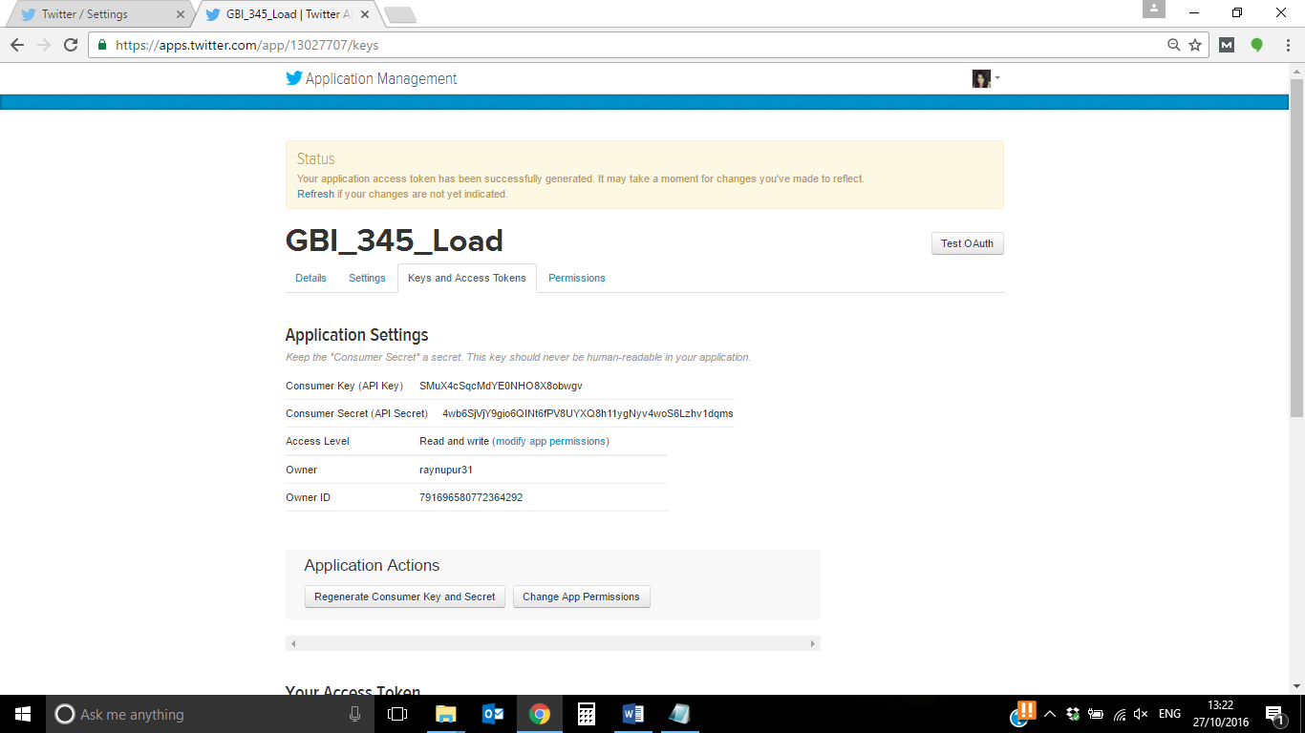

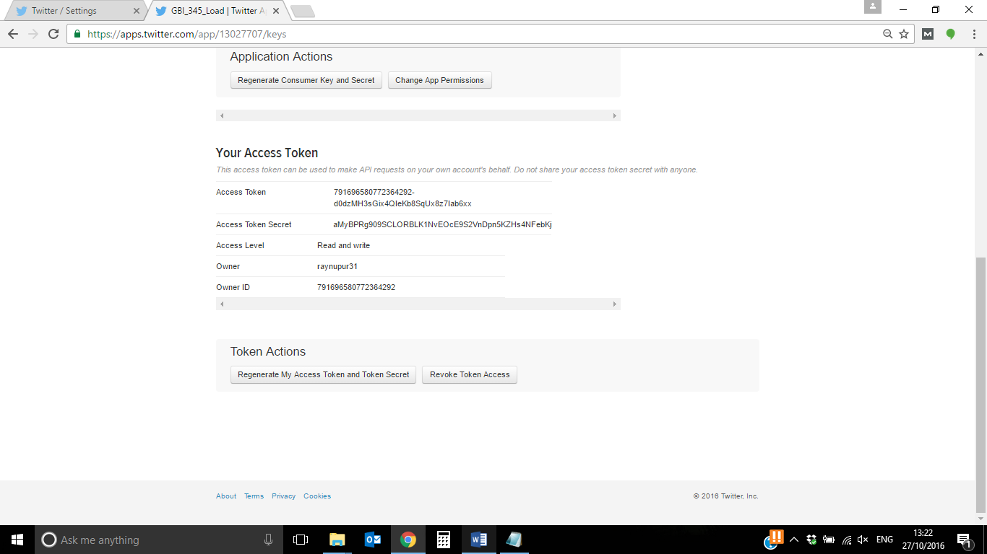

**2) Configure the Twitter adapter for your SAP HANA system**

For loading data from twitter into the SAP HANA database, you need to configure a Remote Source for the Twitter adapter.

Open the Catalog of your system in a browser using the Web IDE.

<http://hd1.hana.ucc.uwm.edu:8003/sap/hana/ide/catalog/>

Then go to:

Provisioning ► Remote Sources.

Right click on folder Remote Sources and choose **New Remote Source**.

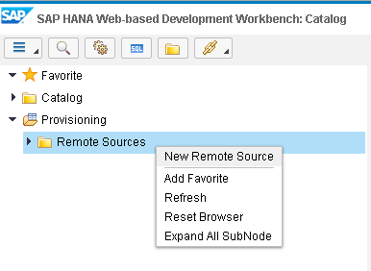

A new screen for configuring a remote source opens.

Enter the following data:

|  |  |
| --- | --- |
| Source Name | GBI_### |
| Adapter Name | TwitterAdapter |
| Location | Agent |
| Agent Name | DPAGENT3 |

It should look as in the following screenshot.

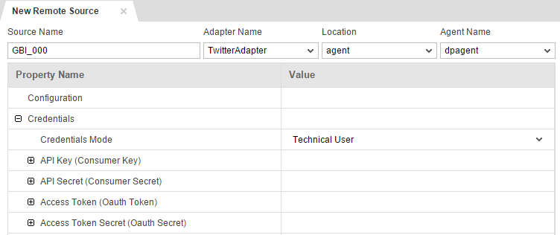

Now click on the + symbol next to API Key, API Secret, Access Token and Access Token Secret to elapse the fields for entering the keys.

Go to your Twitter app and copy and paste the API Key, API Secret, Access Token and Access Token Secret into the corresponding fields.

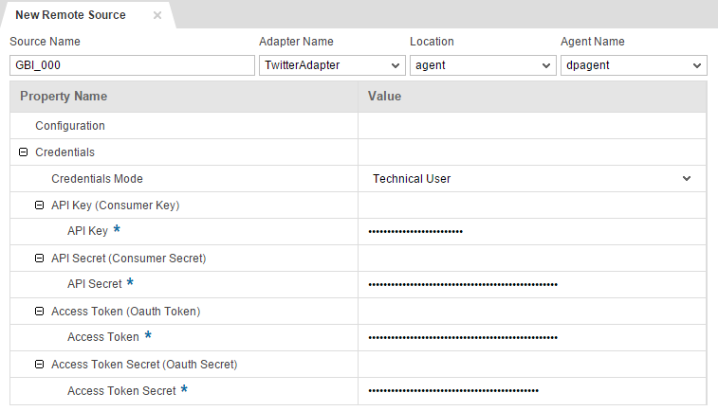

Click on Save  to create the remote source. If your remote source was created successfully, you will get a confirmation and it will be shown on the left side under folder “Remote Sources”.



**Paste a screenshot here.**

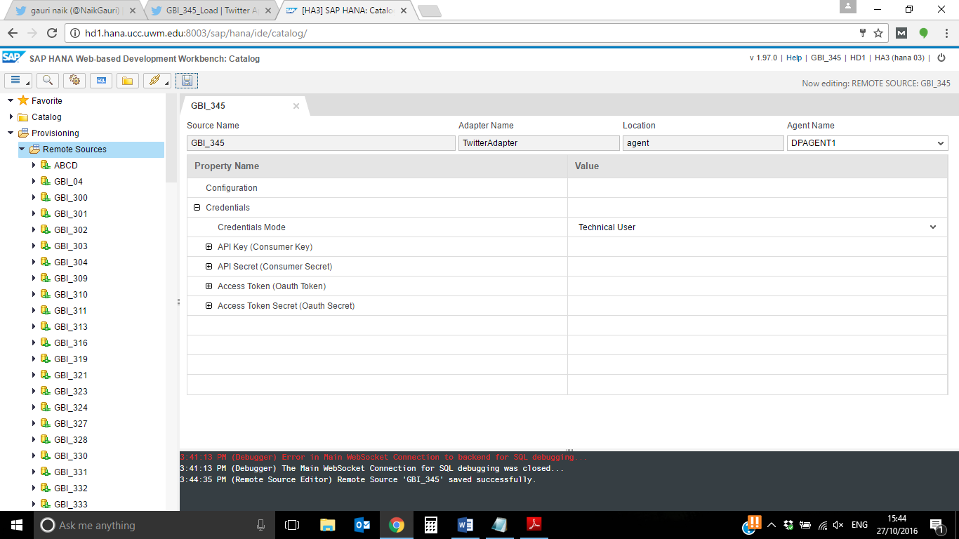

**New:**

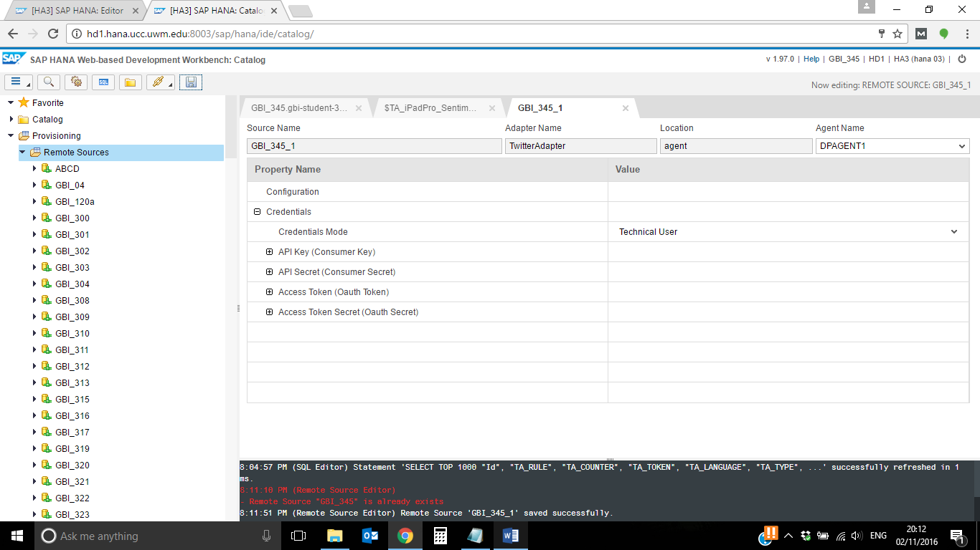

When you elapse your Remote Source now, you can see that there are two tables for loading data, Status and Rate_Limit_Status.

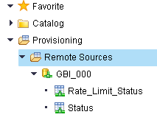

The table “Status” contains your home_timeline and can be used for requesting user’s timelines or searching via the Twitter API.

The table “Rate_Limit_Status” gives you information about your rate limits. In order to control the use of the Twitter API Twitter has a limit per user how often the API can be used per hour. The limit is divided into 15 minute intervals. Depending on the method you are using, you can call it up to 15 times per 15 minutes or up to 180 times per 15 minutes. Strategies to avoid exceeding the rate limit are caching, prioritizing active users or using an application-only auth.

**Paste a screenshot of your remote source.**

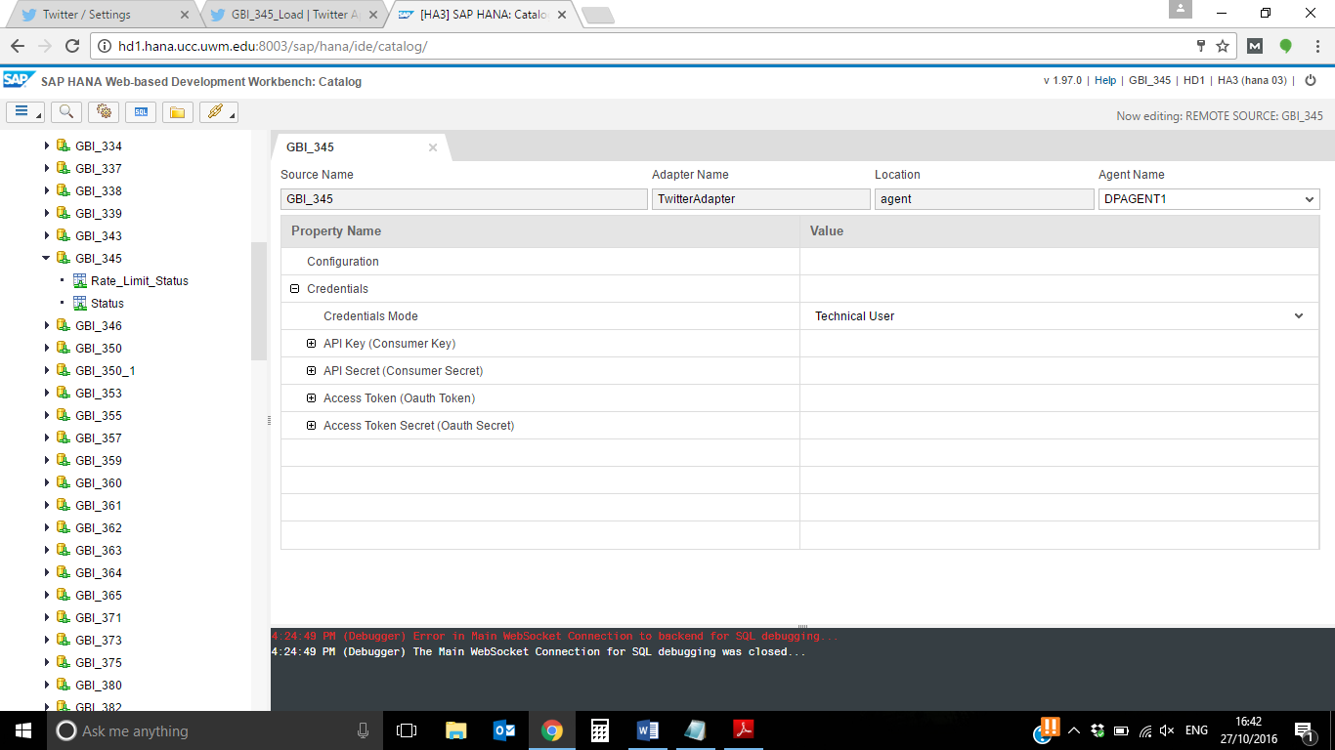

**New:**

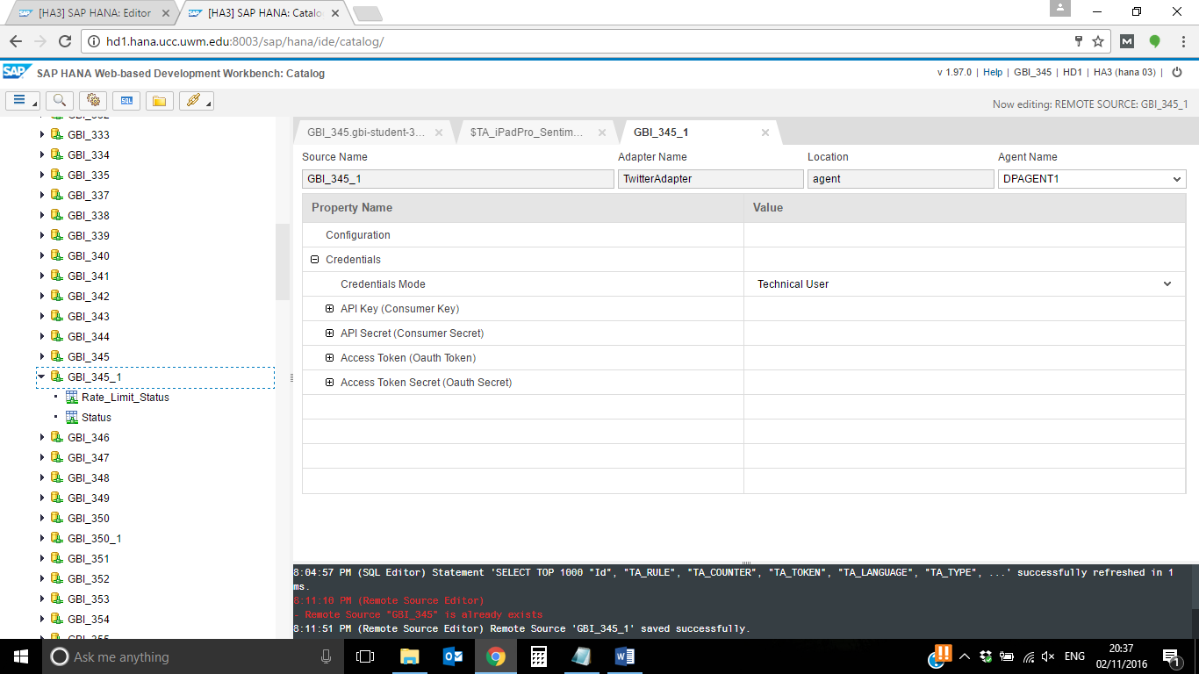

**3) Find the best way to load data from Twitter for later analysis.**

We need to get an insight as to how the Twitter Adapter of SAP HANA Data Provisioning works. Therefore, load the user timeline of Microsoft to find out how the data looks like.

We want to have a look on the timelines of Apple Inc. and Microsoft to find information that could be interesting for Sentiment Analysis.

Go to twitter.com and login to your account. In the upper right corner there is a search field to search for users or for any terms. Type in “Apple” or “Microsoft” to find Apple’s and Microsoft’s official user timeline.

When you type in “Apple”, you will find some results, but please be careful. Apple has an official account on twitter with user name “@Apple”, however, this isn’t broadly used and has just a few followers. Apple owns several Twitter accounts that represent different divisions of the company, e.g. @iTunes or @AppStore. That’s why you won’t be able to find a timeline for the whole company Apple Inc. with useful data.

The next screenshot shows the result that you will receive when searching for the term “Apple”.

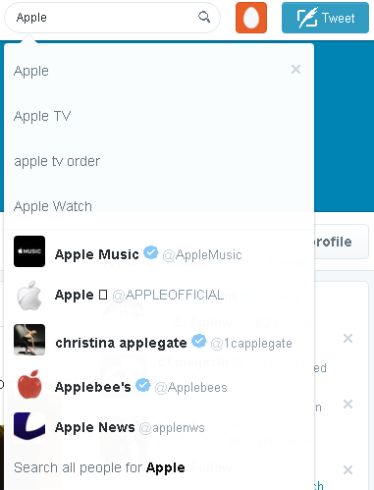

The first entry with the name “@Microsoft” is the official twitter account of Microsoft. Click on it to open the user timeline.

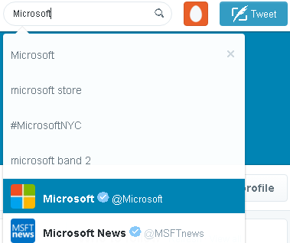

The screenshot on the next page shows Microsoft’s timeline.



Scroll down to find some interesting tweets about the Surface Pro, e.g. the one from the 21st of October 2015 which is shown in the screenshot below.

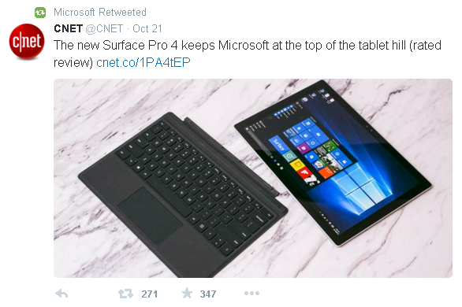

To get an insight how the loaded data looks like, you decide to load the Microsoft’s user timeline into your database.

Open the SAP HANA Web IDE in your browser. For this, please adapt the following link to your system:

[http://hd1.hana.ucc.uwm.edu:8003/sap/hana/ide/editor/](http://hd3.hana.ucc.uwm.edu:8003/sap/hana/ide/editor/)

Login with your user credentials.

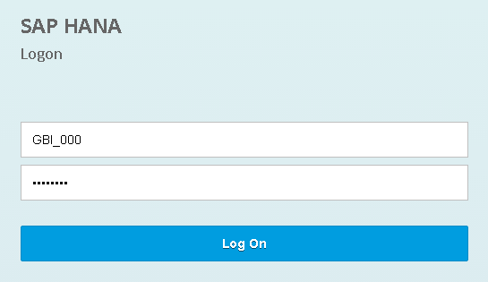

If not already done, you have to create a package first which will hold all the objects you create.

Therefore, right click on “Content” und choose

New ► Package

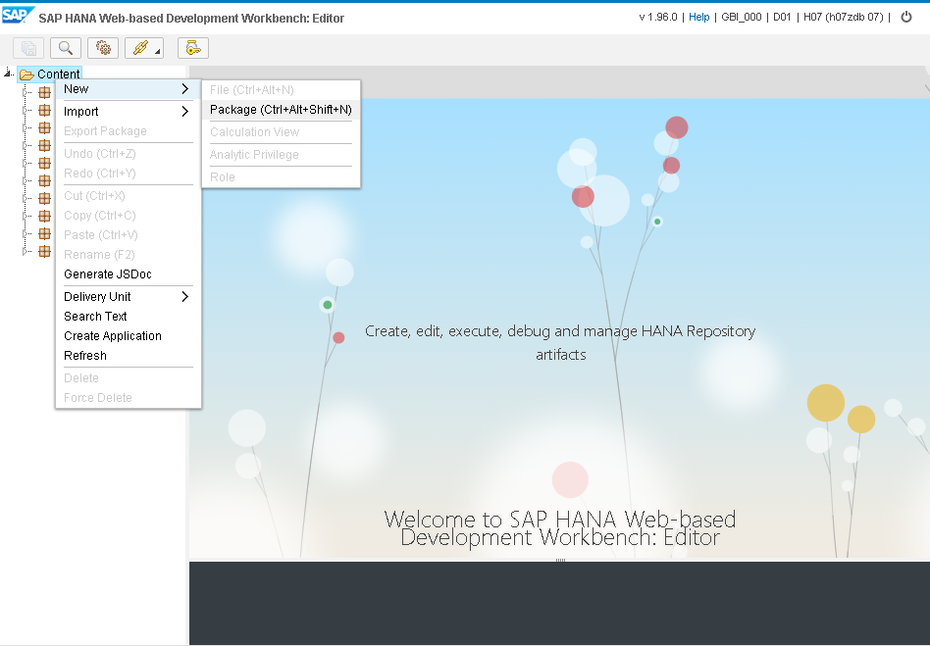

Enter “gbi-student-###” into the field Package name. Replace ### with your student id. Click on **Create** to create the package.

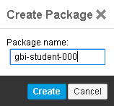

To have a better overview about your content, create an additional package within the gbi-student-### package. Therefore, right click on the package “gbi-student-###” and choose

New ► Package

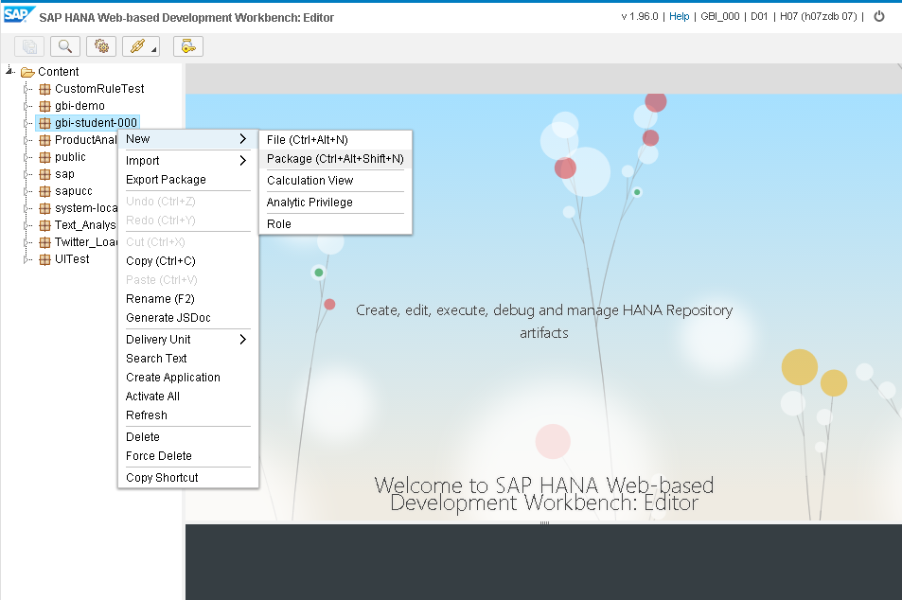

Enter “TwitterLoad” into the field Package name. Click on **Create** to create the package.

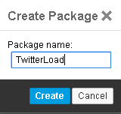

**What is the status message?**

[01:31:11] Package /GBI_345/gbi-student-345_1/TwitterLoad created successfully.

**Paste a screenshot of the package created.**

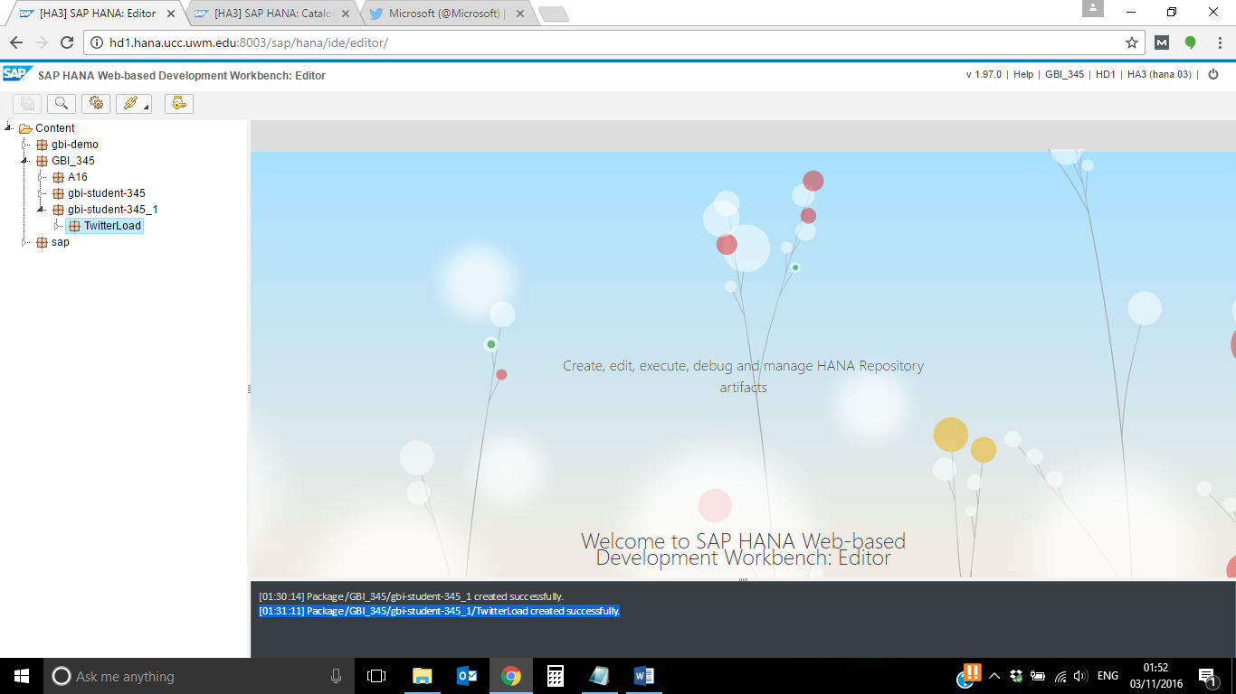

One way to load data into the SAP HANA database is to use a SAP HANA Replication Task. To create such a task, right click on the package “TwitterLoad” and choose

New ► File

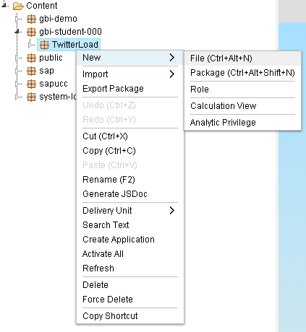

Enter “**Microsoft_timeline_###.hdbreptask**” into the field “**File name**”. Make sure to replace ### with your student id.

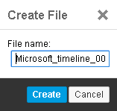

Files containing the file ending “hdbreptask” are used for replicating tables from different data sources into the SAP HANA database.

Choose the Remote Source you created in the previous steps (GBI_###). The data will be loaded via your remote source then.

For the field “Target Schema” and “Virtual Table Schema” choose your user’s schema (GBI_###). That means that the virtual table and the replicated table will be stored in your schema GBI_###.

Enter “VT” into the field “Virtual Table Prefix”, so that the virtual table will start with “VT”. That’s necessary to differentiate between the virtual and the replicated table.

Uncheck “Drop target table if exist” and “Initial load only”. That means that new entries that occur in the source table will be added to the replicated table.

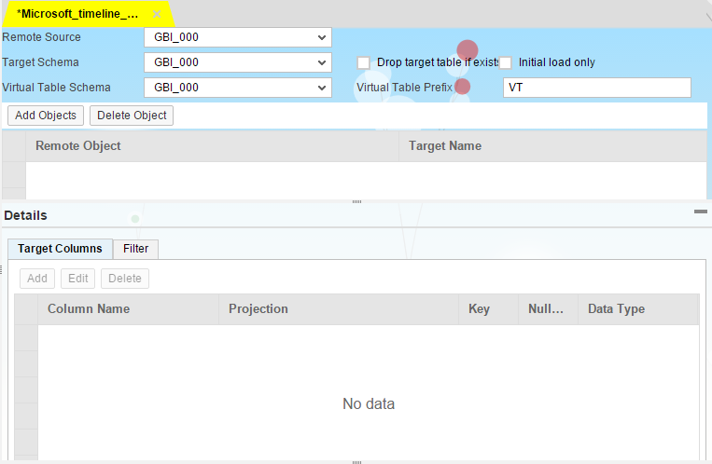

Click on **Add Objects** and choose the entry with table “Status”. Click on **OK** to add the object to your Replication Task.

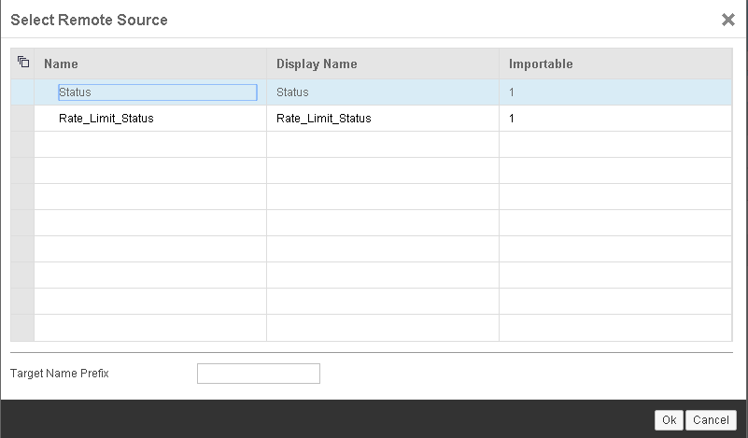

Afterwards the objects will be shown in the table. It should look like shown in the following screenshot.

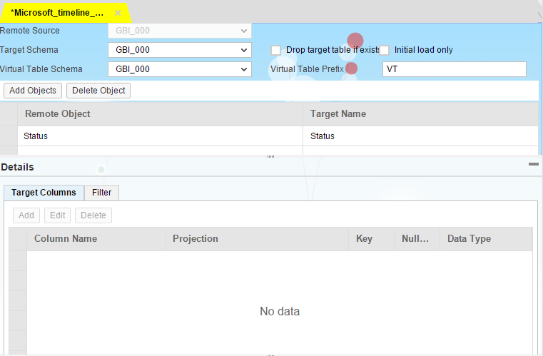

If you cannot see the objects, drag and drop the horizontal divider to make them visible.

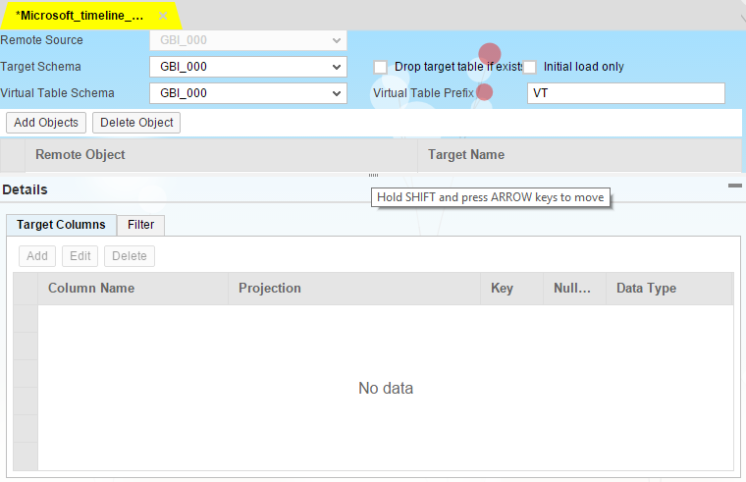

The actual name for the table that will be created in the SAP HANA database is “Status”. As we want to differentiate between different replicated tables, change the Target Name in the table to “Microsoft_timeline_###” (replace ### with your student id).

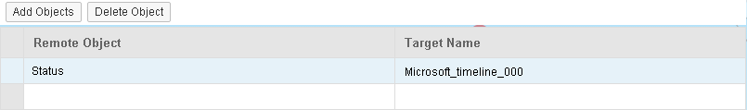

To filter the virtual table for a user timeline, you have to add a filter for the timeline. Therefore, click on the line with the created object and go to tab “Filter” in the Details section. Enter the following statement into the text field:

"ScreenName" = 'Microsoft'

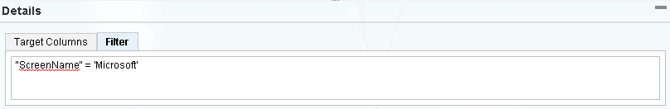

Click on the Save button to save and activate the replication task. You will get a confirmation that it was created and activated successfully.

[12:01:27] File /GBI_345/gbi-student-345_1/TwitterLoad/Microsoft_timeline_345_1.hdbreptask saved & activated successfully.

**Paste a screenshot of status message.**

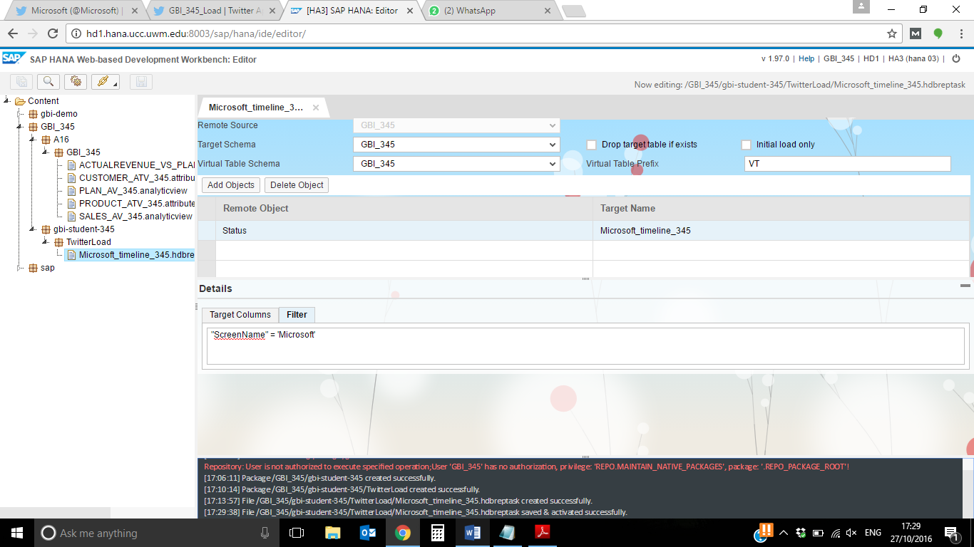

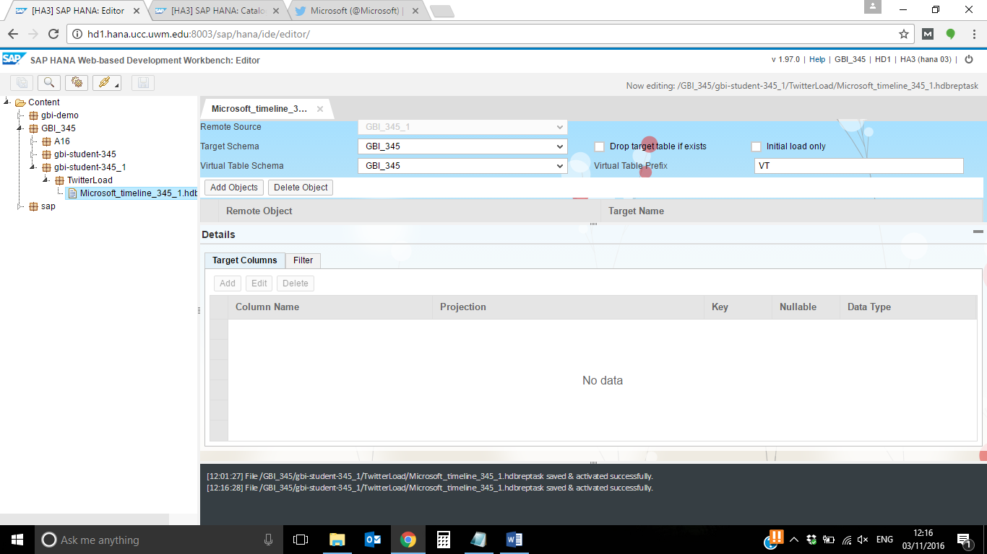

By activating the task, a procedure to replicate the data will be created. You have to execute it once manually to replicate the data. Go to the Catalog of your system using the Web IDE:

<http://[FQDN]:[HTTP-Port]/sap/hana/ide/catalog/>

Open the following path:

Catalog ► GBI_### ► Procedures

You can see that a new procedure has been created. Right click on it and choose **Open Definition.**

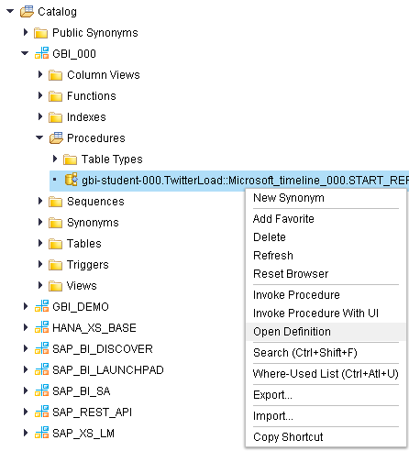

Click on the tab “Create Statement” to see the code of the procedure.

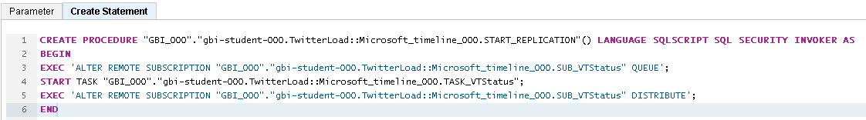

To open the SQL statement to execute the procedure, click on **Invoke Procedure** at the upper-right corner. A SQL console will be opened and you just need to click on the **Execute** button  in the menu bar to execute the procedure.

You receive a confirmation that the procedure was executed successfully.



**Paste a screenshot of the status message.**

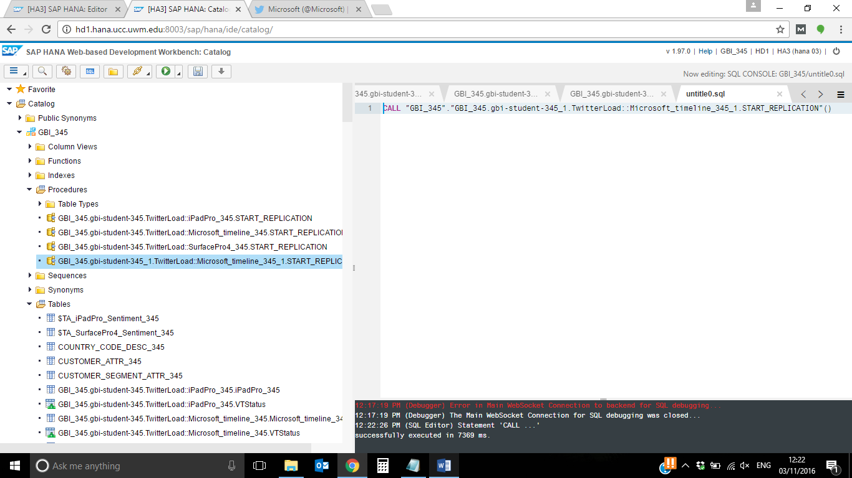

Elapse the folder “Tables” under

Catalog ► GBI_###

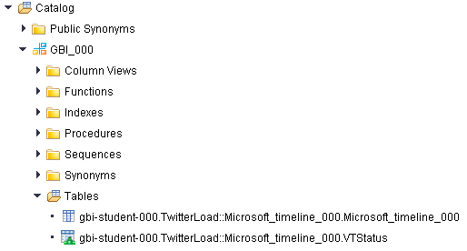

As you can see, two new tables have been created by executing the procedure: gbi-student-###.TwitterLoad::Microsoft_timeline_###.VTStatus and gbi-student-###.TwitterLoad::Microsoft_timeline_###.Microsoft_timeline_###.

The table with the ending “VTStatus” is a virtual table. If you open the definition of this table, you can see that the table type is “VIRTUAL”.

The table with the ending “Microsoft_timeline_###” is the table with the replicated data. It has the same structure like the virtual table but the content is filtered for the screen name “Microsoft”. Right click on the table and choose **Open Definition**. The type of the table is “COLUMN” which means that it is a column store table in the SAP HANA database.

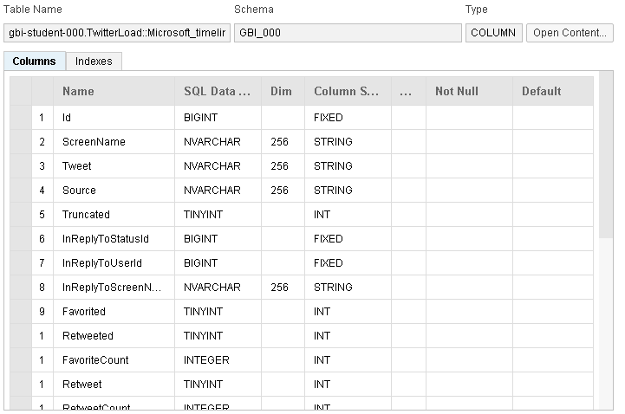

Now click on the button **Open Content** in the upper right corner. You can see that tweets of Microsoft’s user timeline are stored in the table. You can also see that there are tweets that start with “RT”. These are the Tweets Microsoft has retweeted. There are 1000 rows in the table. That is because the Twitter adapter only loads the 1000 recent tweets at a time.

Please note: The screenshots in this case study can be different as it deals with live data!

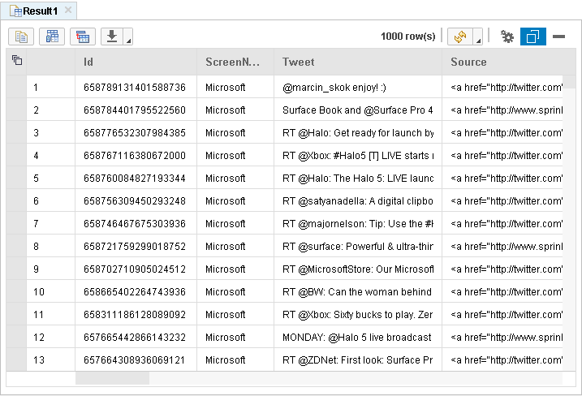

**Paste a screenshot of your table.**

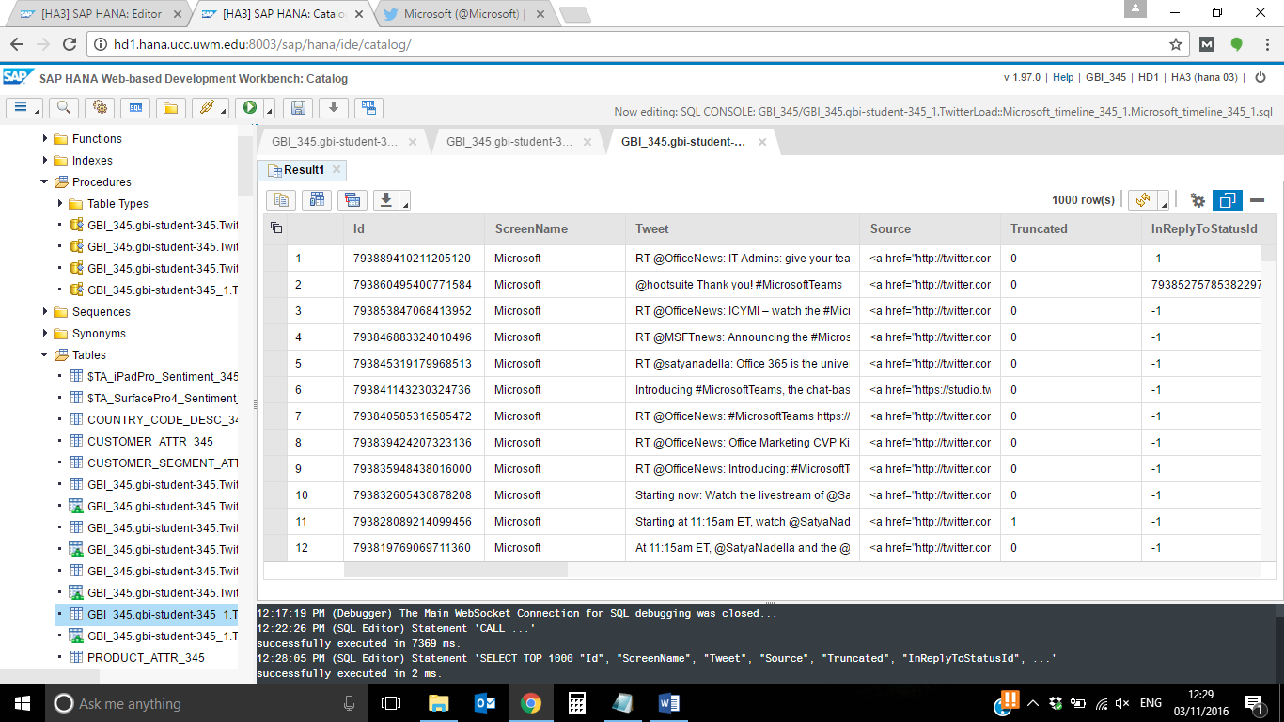

If you scroll to the right of the table, you can also see which Tweets are a reply from Microsoft to someone’s Tweet. You can also see how many times a tweet of Microsoft was retweeted.

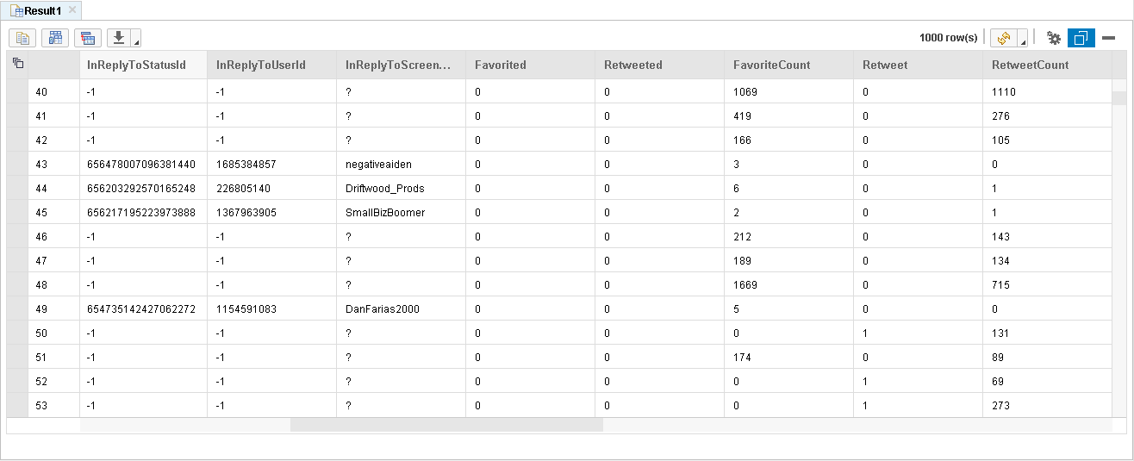

**Replies from Microsoft**

**Retweet count**

As you can see, there is no column for the content of the Retweets Microsoft received for their Tweets. Unfortunately, that’s why you decide that it doesn’t help you to load user timelines for analyzing data with Sentiment Analysis.

**4) Load Tweets using the Twitter Search API.**

Load Tweets about the Surface Pro 4 and the iPad Pro. Use SAP HANA Replication Tasks to replicate the data to the SAP HANA database.

As it doesn’t help you to load user timelines for collecting data for Sentiment Analysis, you need to find another way to load interesting data. Twitter users use hashtags to tag their Tweets with relevant keywords. You can search for hashtags using the Search API of Twitter.

Go back to your Twitter account in the browser and type “iPad Pro” into the search field on the upper right corner. Scroll down to find a Tweet that uses a hashtag which is related to the iPad Pro. Click on the link to see all tweets containing this hashtag (see screenshot below).



You can find a lot of Tweets from different users in different languages for this hashtag. You can do the same with the Surface Pro 4. Click into the search field on the upper right corner and type in “Surface Pro 4”. Then find a Tweet containing the hashtag “#SurfacePro4”. For us it is easier to take the terms “iPad Pro” and “Surface Pro 4” for our search. So we can make sure that we will get all Tweets because not everyone is using hashtags.

Go to the Editor perspective in the Web IDE again:

<http://hd1.hana.ucc.uwm.edu:8003/sap/hana/ide/editor/>

Right click on the package

gbi-student-### ► TwitterLoad

and choose

New… ► File

Enter “iPadPro_###.hdbreptask” for the file name and click on **Create**.

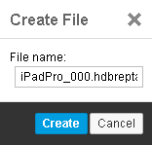

Choose the Remote Source you created in the previous steps (GBI_###). For the field “Target Schema” and “Virtual Table Schema” choose your user’s schema (GBI_###). Enter “VT” into the field “Virtual Table Prefix”. Uncheck “Drop target table if exist” and “Initial load only”. It should look like shown in the next screenshot.

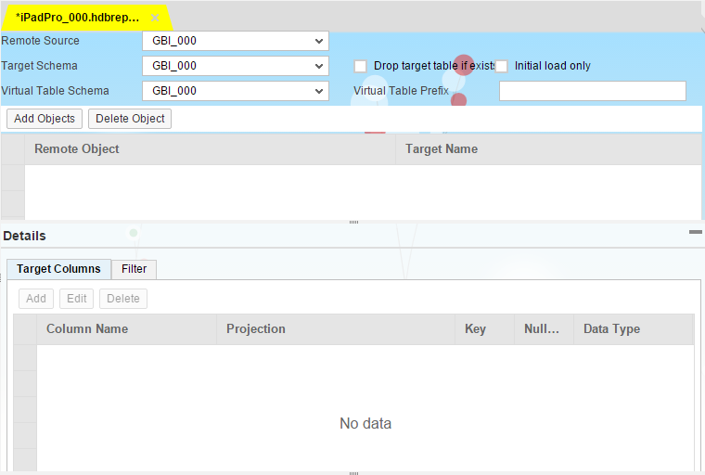

Click on **Add Objects** and choose the entry with table “Status”. Click on **OK** to add the object to your Replication Task.



Change the Target Name in the table to “iPadPro_###” (replace ### with your student id).

Next we need to ensure that a primary key will be created for the table with the replicated data. This is very important for further analysis because to do Text Analysis on a table, you need to create a Fulltext Index. An index can only be created for tables with primary keys. Click on the column “Id” under the tab Target Columns. Then click on the button **Edit** at the top of the table. In the pop-up uncheck the checkbox “is nullable” and check “is part of the primary key”. This ensures that the column “Id” will be used as the primary key for the table. Click on **Ok** to save your changes.

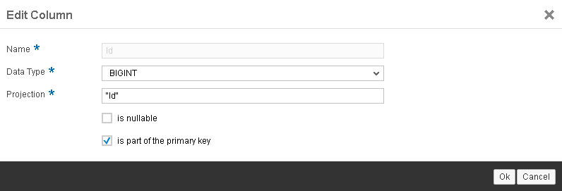

Your replication task should look as shown in the screenshot below, now:

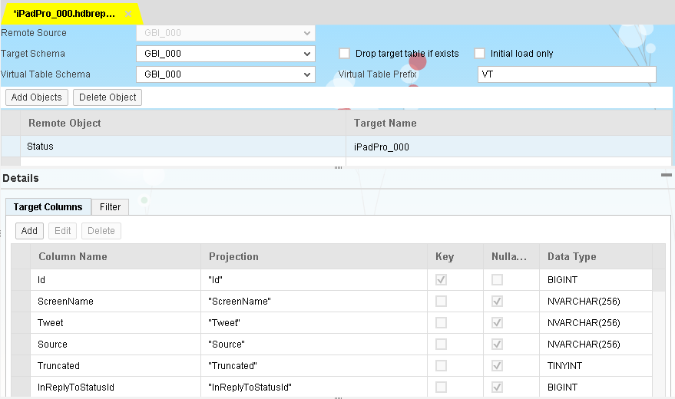

**Paste your screenshot here.**

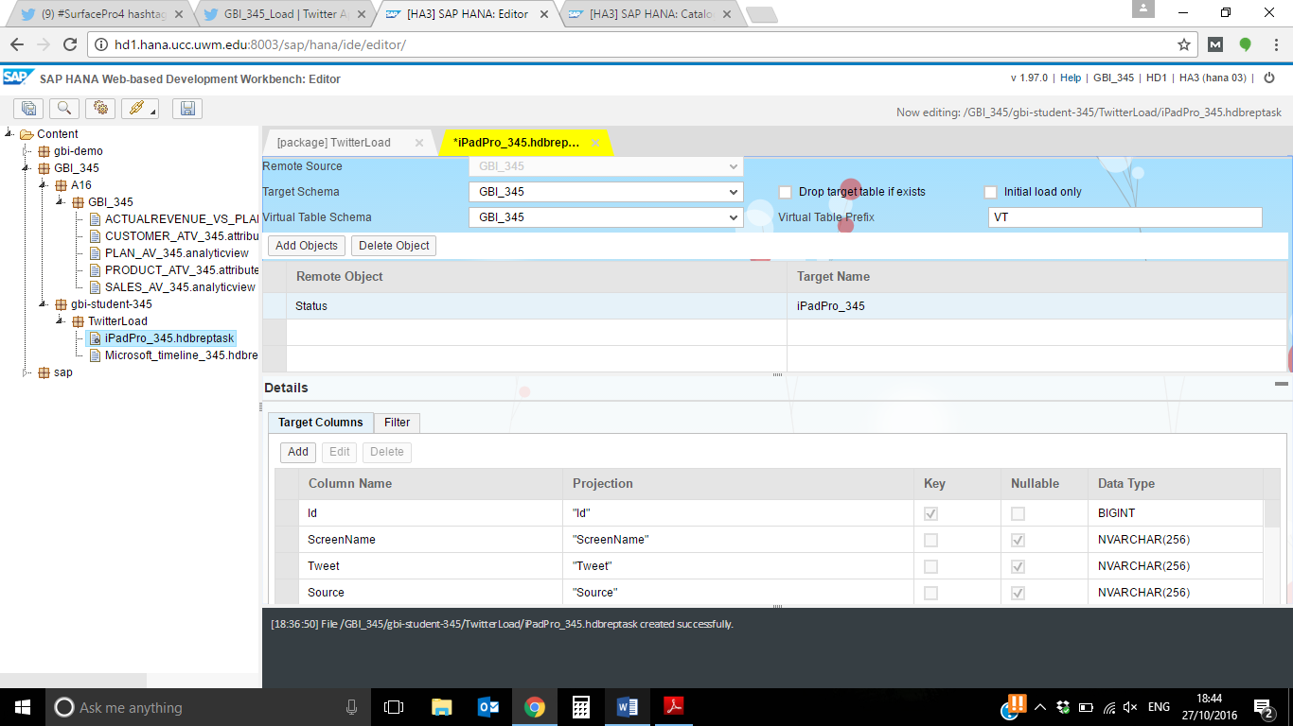

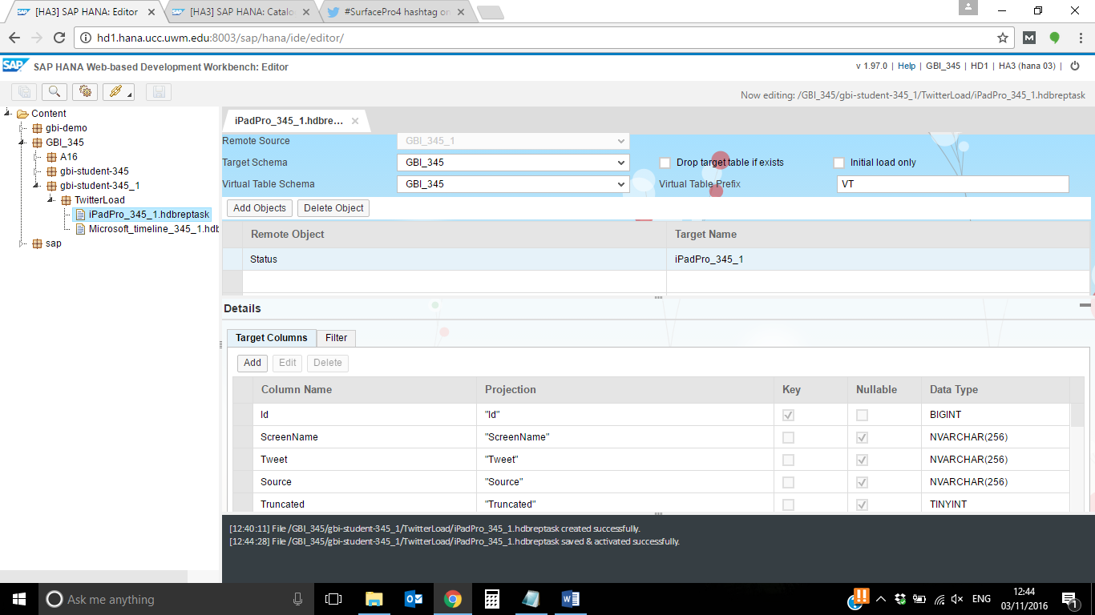

Afterwards change to the tab “Filter” in the Details view and copy the following statement to the text field:

"Tweet" LIKE 'iPad Pro'

This statement tells the TwitterAdapter to use the Twitter Search API which searches for all Tweets including the term “iPad Pro”. Your replication task should look like shown in the next screenshot.

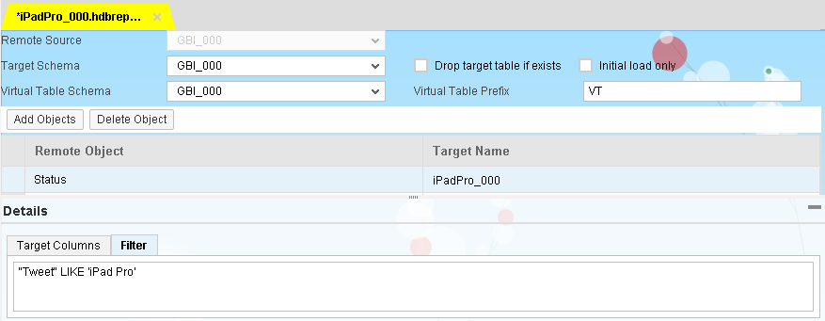

**Paste your screenshot here.**

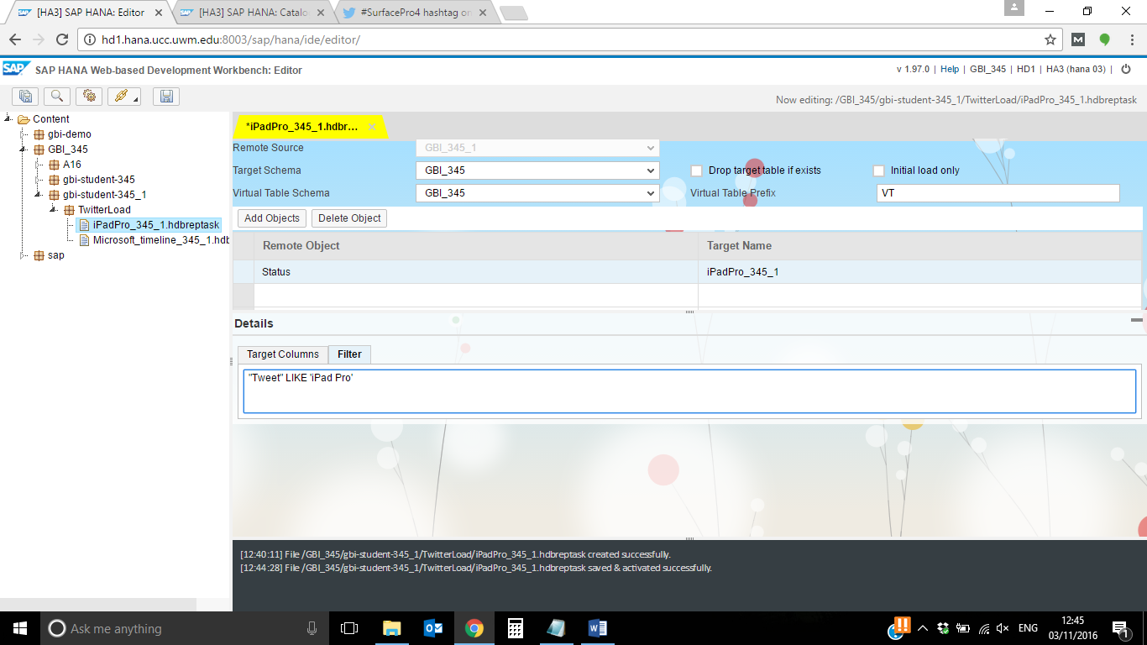

Click on save to save and activate the replication task.

Let’s have a look at the Rate Limit table to see what is happening if you do a call to the Twitter API.

Go to the Catalog of your system using the Web IDE:

<http://hd1.hana.ucc.uwm.edu:8003/sap/hana/ide/catalog/>

Then go to:

Provisioning ► Remote Source ► GBI_###

Right click on the table “Rate_Limit_Status” and choose **New virtual table**.

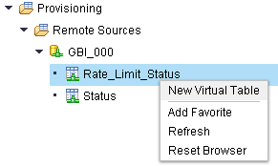

Enter Rate_Limit_Status_### for the table name (replace ### with your student id).

Select your schema GBI_### (replace ### with your student id).

It should look like shown in the next screenshot.

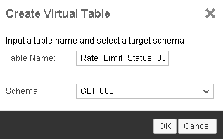

Click on **OK** to create the virtual table. Then go to

Catalog ► GBI_### ► Tables

If your table is not shown under the folder "Tables", right click and the folder and choose **Refresh**. Right click on the table “Rate_Limit_Status_000” and choose **Open Content**.

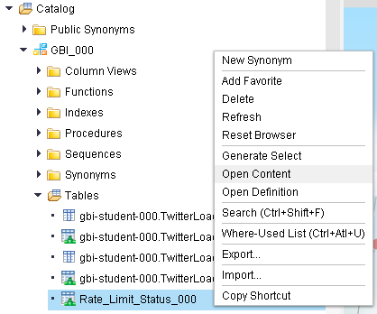

In the result table you can see various rate limits. The column “endpoint” contains the type of data for that you call the Twitter API. The column “limit” contains the number of calls you are allowed to do for that type. The column “remaining” contains the number of remaining calls you have. The column “secondsUntilReset” contains the time in seconds until your remaining calls are reset to the rate limit.

In this case you can see that you have just called the function “application/rate_limit_status” once, when opening this table to look up your rate limit.

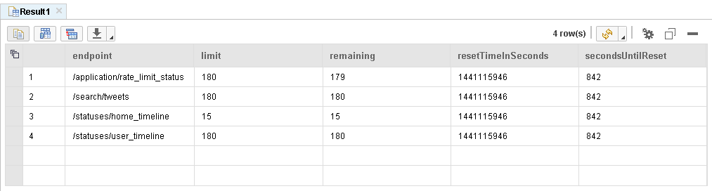

**Paste your screenshot here.**

I pad pro

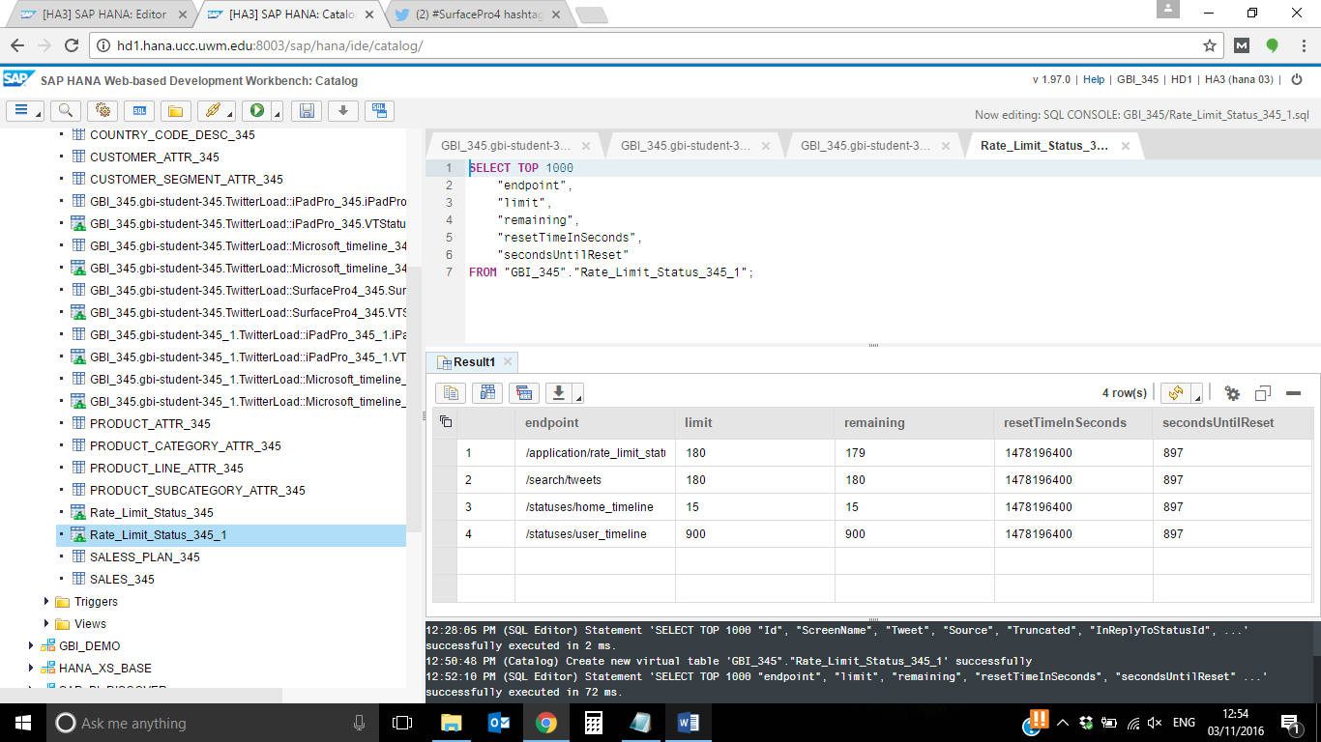

Surface pro-

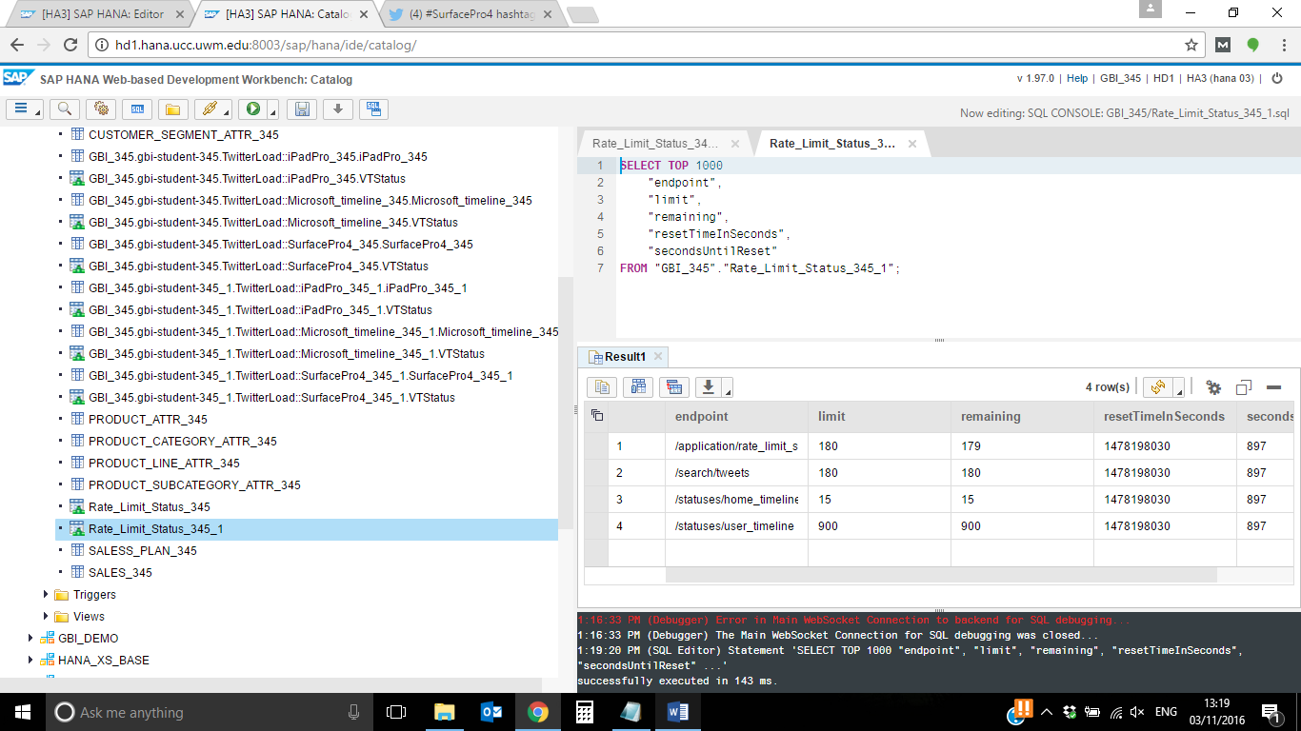

Now we want to replicate all Tweets including the term “iPad Pro” into the SAP HANA database.

Therefore, we have to execute the SAP HANA Replication Task we created in the previous steps.

Open the following path

Catalog ► GBI_### ► Procedures

Right click on “ gbi-student-###.TwitterLoad::iPadPro_000.START_REPLICATION” and choose **Invoke Procedure**.

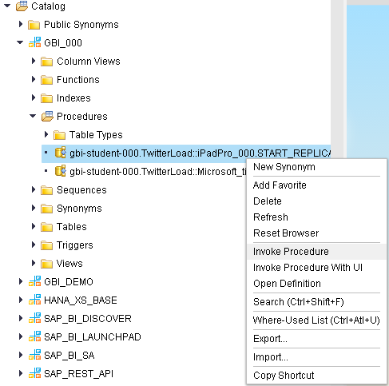

Click on the Execute button  in the menu bar to execute the procedure. It needs some time to replicate the data.

Surface pro –

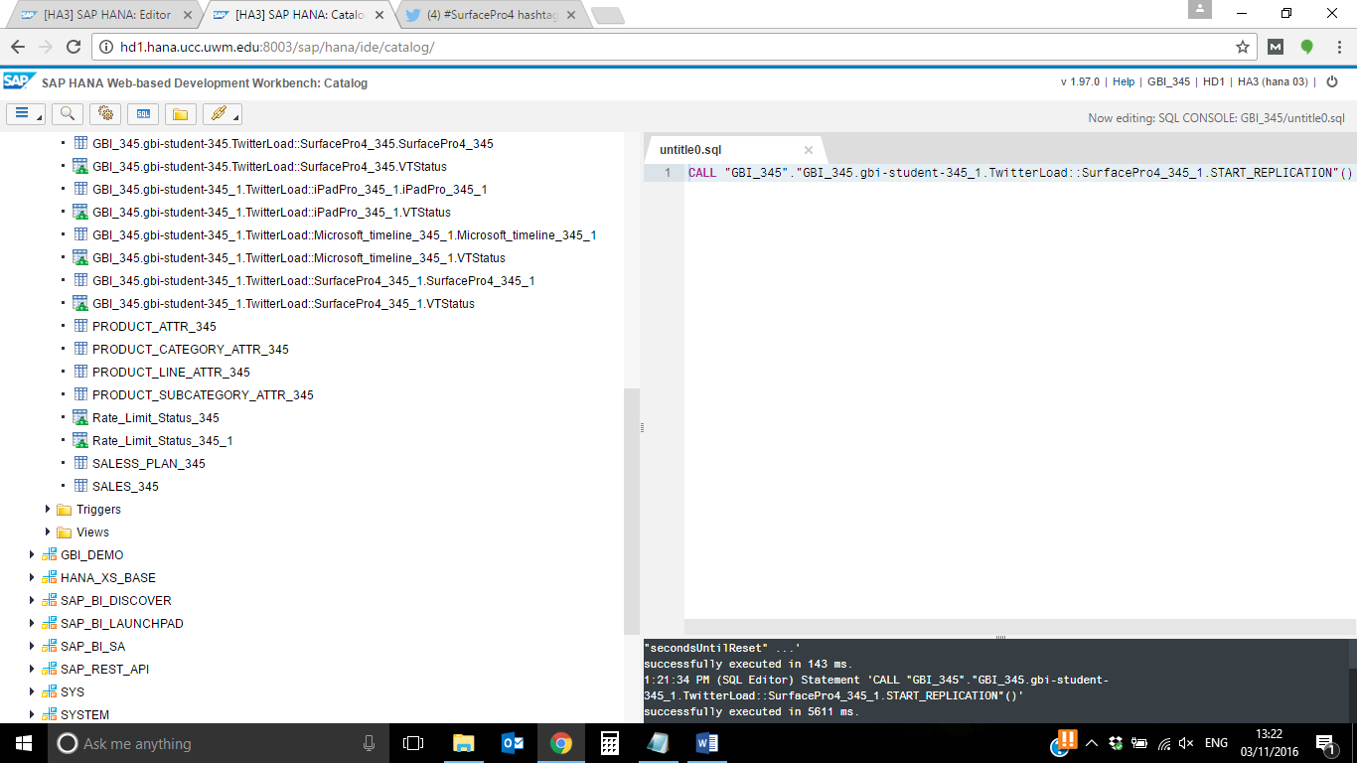

If you open the content of the table “Rate_Limit_Status_###” (replace ### with your student id) once again and press the **Refresh**  button, you can see that the remaining calls for the endpoint “/search/tweets”, i.e. the Search API, are now set to 168. That means that the call you did to the Search API has consumed 12 calls. You can do 180 calls per 15 minutes to the Search API. If you wait for 878 seconds, your remaining limit will be reset to 180 again.

Please note: It is possible that the remaining calls are set to a different value in your case (e.g. 170).

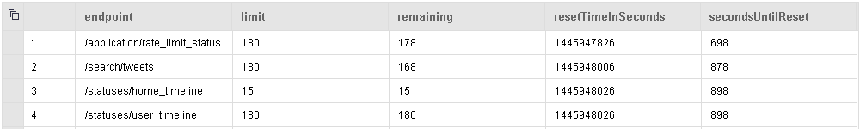

**Paste your screenshot here.**

I pad pro-

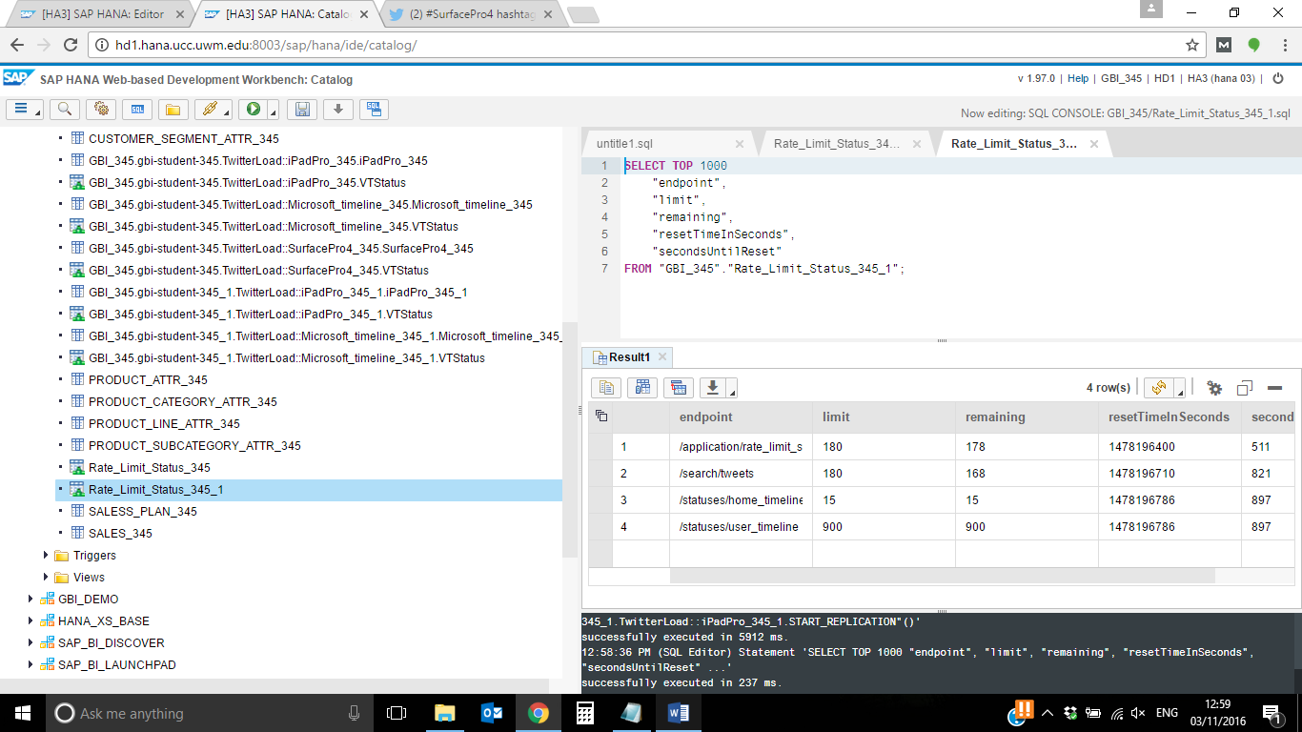

Surface pro4-

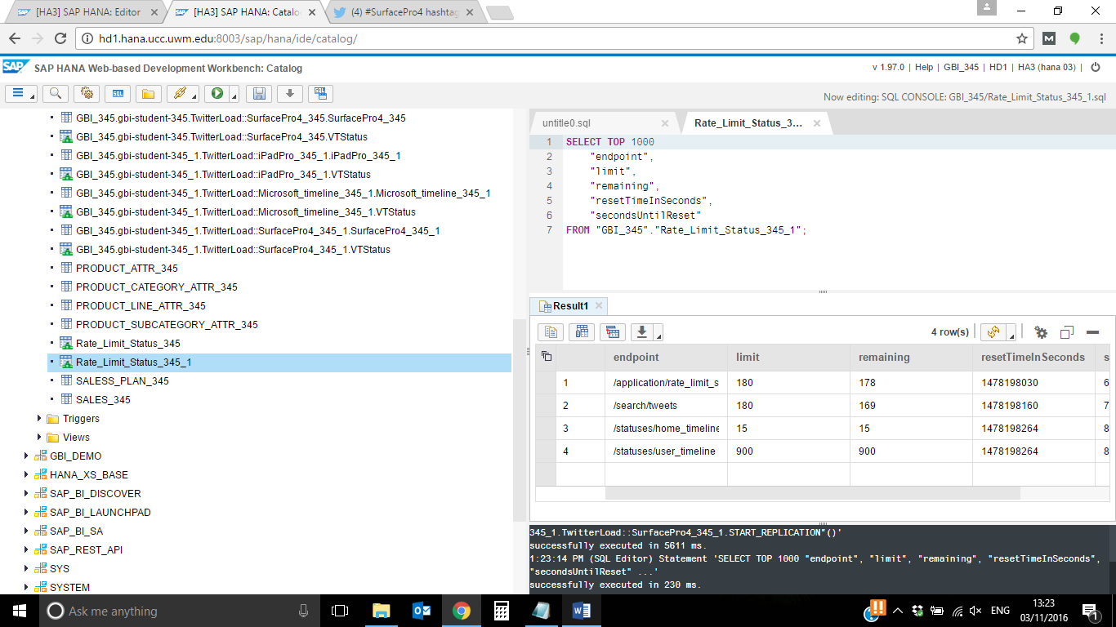

**Question) How many calls are left for endpoint “/search/tweets”?**

**iPad Pro -168**

**Surface Pro 4- 169**

Next we want to have a look at the table content with the data of term “iPad Pro”.

Go to

Catalog ► GBI_### ► Tables.

You can see that two new tables are created:

gbi-student-###.TwitterLoad::iPadPro_###.iPadPro_### and

gbi-student-###.TwitterLoad::iPadPro_###.VTStatus.

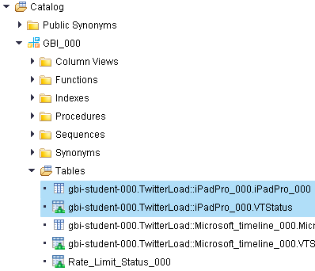

Right click on “gbi-student-###.TwitterLoad::iPadPro_###.iPadPro_###” and choose **Open Content**.

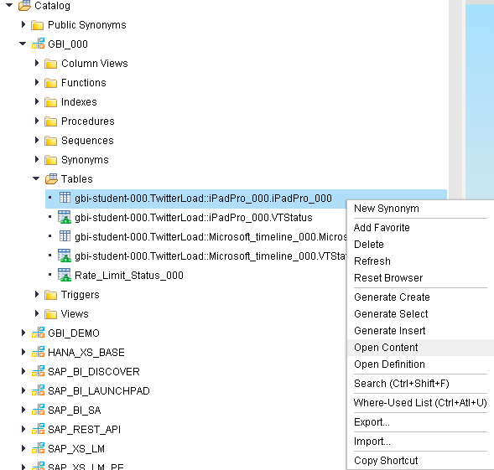

As you can see, the table contains Tweets from different users now. If you scroll to the right to column “isoLanguageCode”, you can also see that the language of the Tweet is identified. Some Tweets appear multiple times because they were retweeted by different users. You can also see the creation date of the post and sometimes the place from which the Tweet was sent.

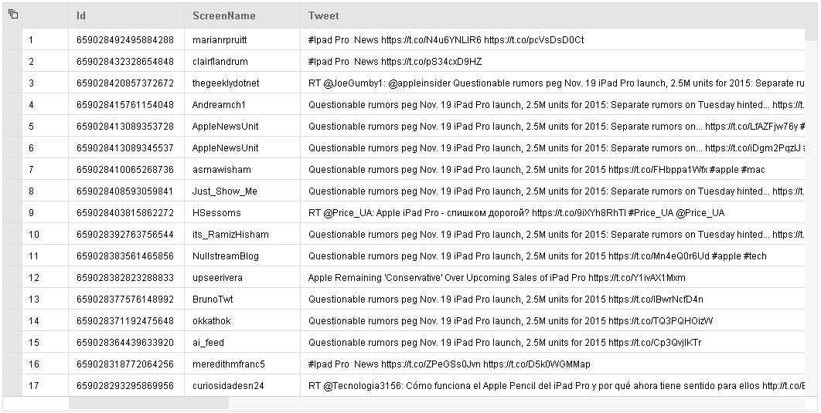

**Creation date/time**

**Language**

**User accounts**

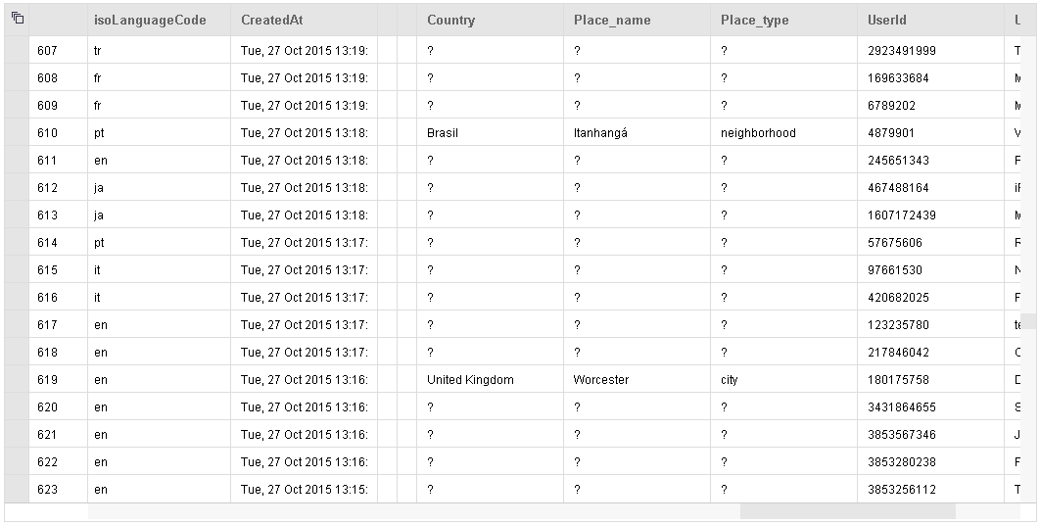

**Location**

**Paste your screenshot here.**

**iPadPro:**

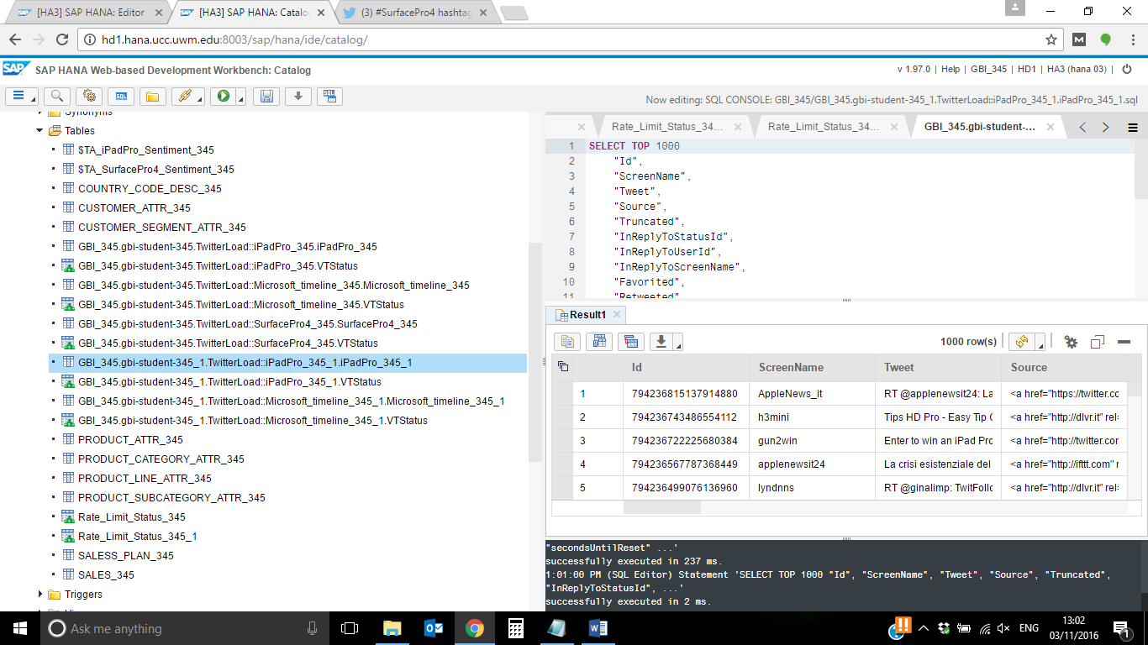

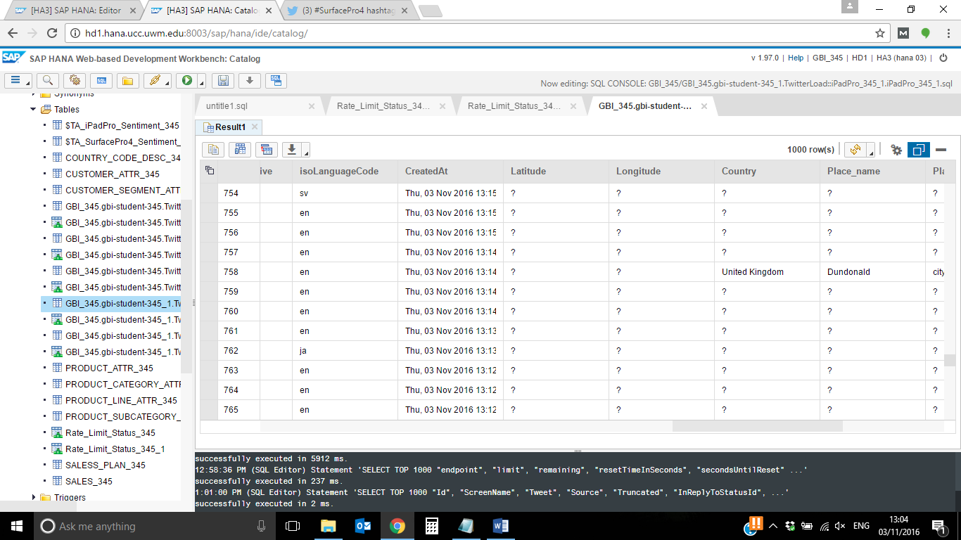

**Surface pro4:**

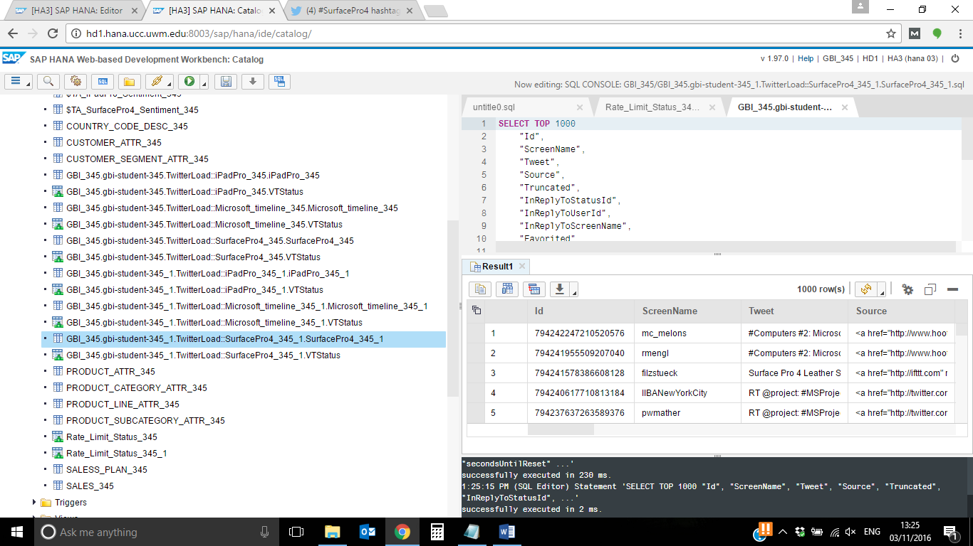

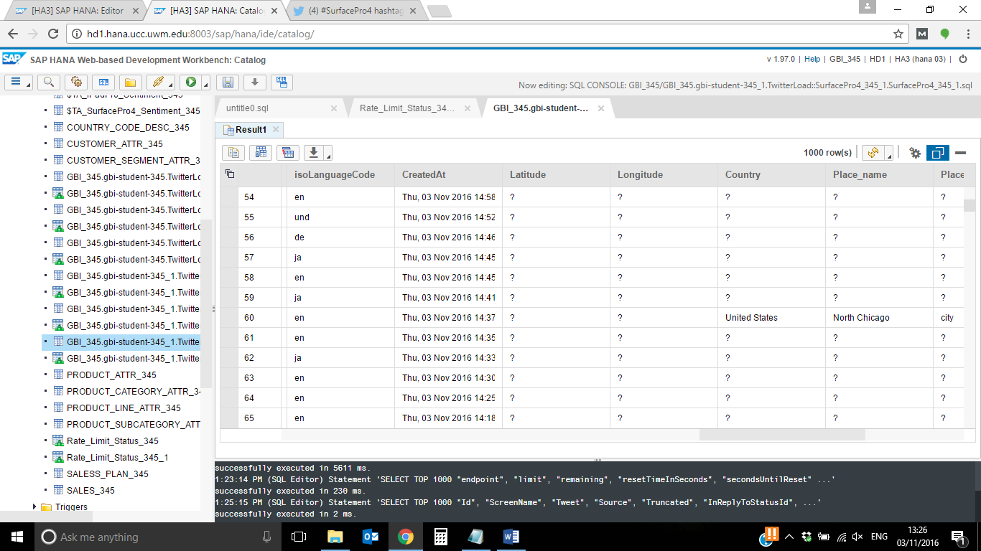

To compare data from the Surface Pro 4 and the iPad Pro, you need to load data about the Surface Pro 4. Repeat the steps from Task 4 for the term “Surface Pro 4”.

Choose “SurfacePro4_###.hdbreptask” as the name for the SAP HANA Replication Task and “SurfacePro4_###” for the table name of the target table. Make sure to replace ### with your student id. Don’t forget to set the column “Id” as the primary key!

The final Replication Task should look like shown in the screenshots below:

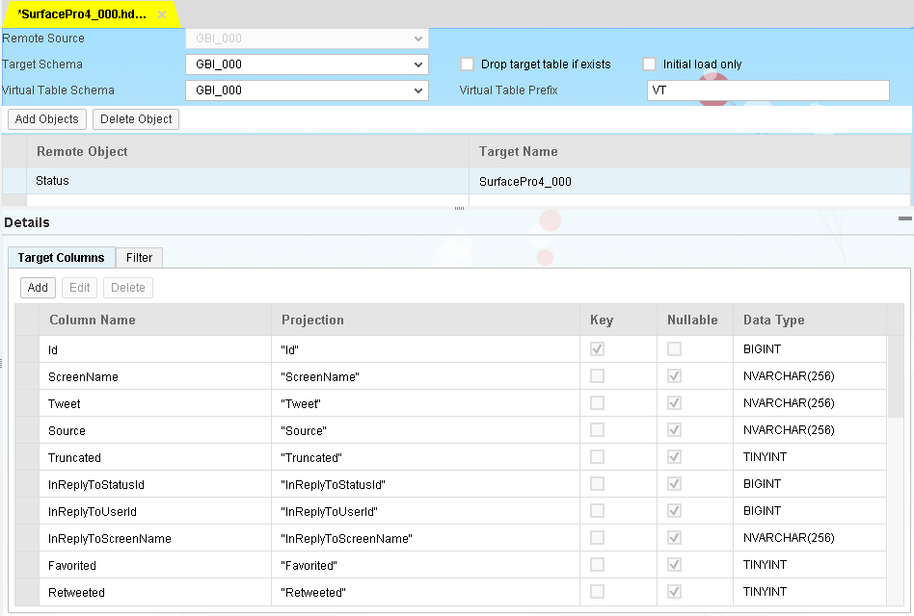

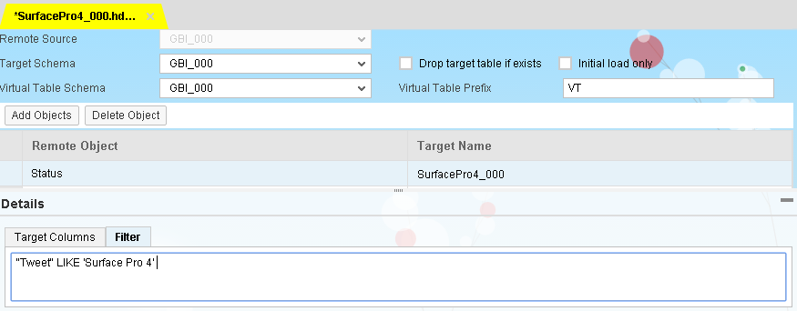

**Paste a screenshot of your final “Surface Pro 4” table.**

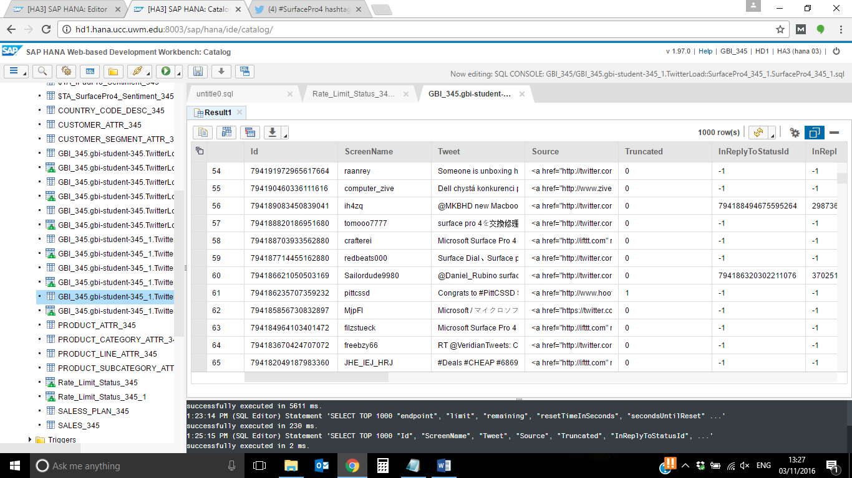

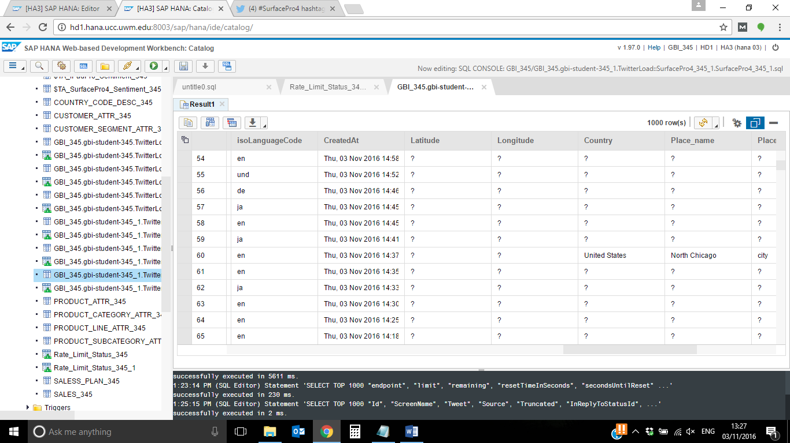

**Objective**

Get familiar with the creation of fulltext indexes and preparation of Twitter data for further analysis.

**Fulltext Index**

We will create a Fulltext Index on the tables that have been filled with Twitter Data in the previous exercise. Then we will have a look at the analysis results that have been created with the fulltext index.

To create a fulltext index you need to execute a SQL statement. This creates a table containing the Sentiment Analysis results.

Open the Catalog of your system in a browser using the Web IDE.

<http://hd1.hana.ucc.uwm.edu:8003/sap/hana/ide/catalog/>

Open a SQL console and enter the following statement (replace ### with your student id).

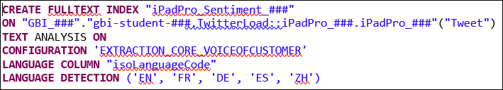

This statement creates a fulltext index for column “Tweet” for the table gbi-student-###.TwitterLoad::iPadPro_###.iPadPro_###. Because of the keywords “TEXT ANALYSIS ON” the system recognizes that you want to do text analysis.

After the keyword “CONFIGURATION” you can add different configuration options. As we want to analyze customers’ opinion about the iPad Pro and the Surface Pro 4, we add the option “EXTRACTION_CORE_VOICEOFCUSTOMER”.

The keyword “LANGUAGE COLUMN” identifies the column which holds a language indicator if available. If you use this addition the SAP HANA database is able to analyze data in various languages (e.g. English, German, Portuguese, Japanese and much more).

The keyword “LANGUAGE DETECTION” tells the preprocessor server to use the given languages for the analysis.

When executing the statement, the preprocessor server of the SAP HANA system searches for different keywords that identify to which sentiment a Tweet belongs.

Open the following path:

**Catalog ► GBI_### ► Tables**

You can see that a new table with the name “$TA_iPadPro_Sentiment_###” was created. The beginning “TA” stands for Text Analysis. The table itself contains the analysis results. Right click on the table and choose **Open Content**.

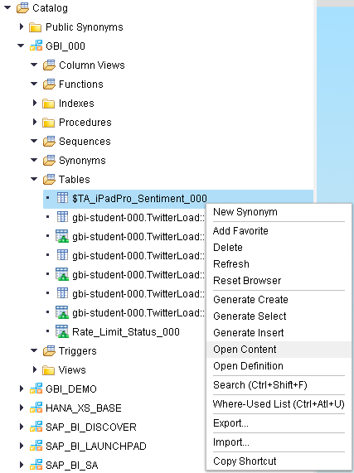

The table contains a lot of different columns with different information that was found during analysis:

**TA_COUNTER:** This counter counts all tokens in a document. In our case a “document” is one row in the database because each row represents one Tweet.

**TA_TOKEN:** Represents the token that was identified. That can be only one word or more and depends on the type that was identified.

**TA_LANGUAGE:** Is the language code for the document, i.e. the language of the Tweet that was taken out of the original database table.

**TA_TYPE:** Contains the linguistic or semantic type of the token. The types of interest for us are for example “WeakPositiveSentiment”, “PositiveSentiment”, “NegativeSentiment” or “MinorProblem” because these types tell us that the identified token is a sentiment, i.e. the opinions of the user who send the Tweet.

**TA_CREATED_AT:** Is the creation time of the index and only used for administrative tasks, e.g. database reorganization.

**TA_OFFSET:** Stores the offset of characters relative to the beginning of the document.

**TA_PARENT:** Stores the TA_COUNTER of the parent token. If it has no parent token the value is null. If, for example, a token that was identified includes two words, there can be two additional rows with the single words.

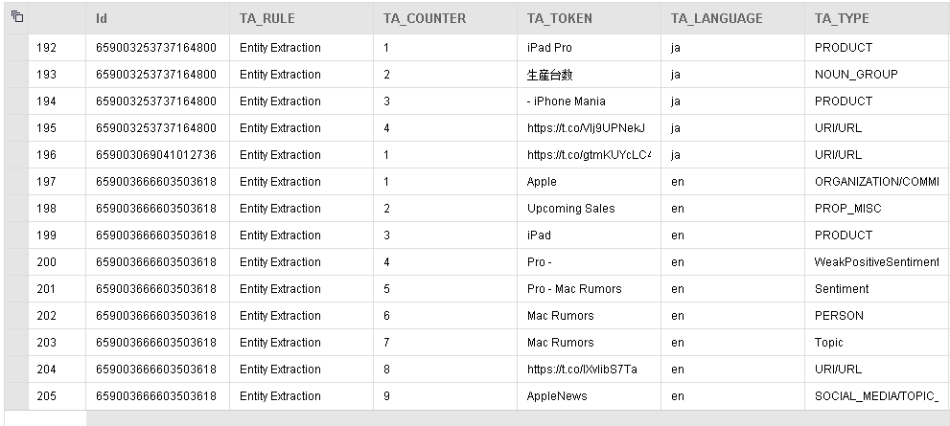

**Paste your screenshot here.**

ipad pro-

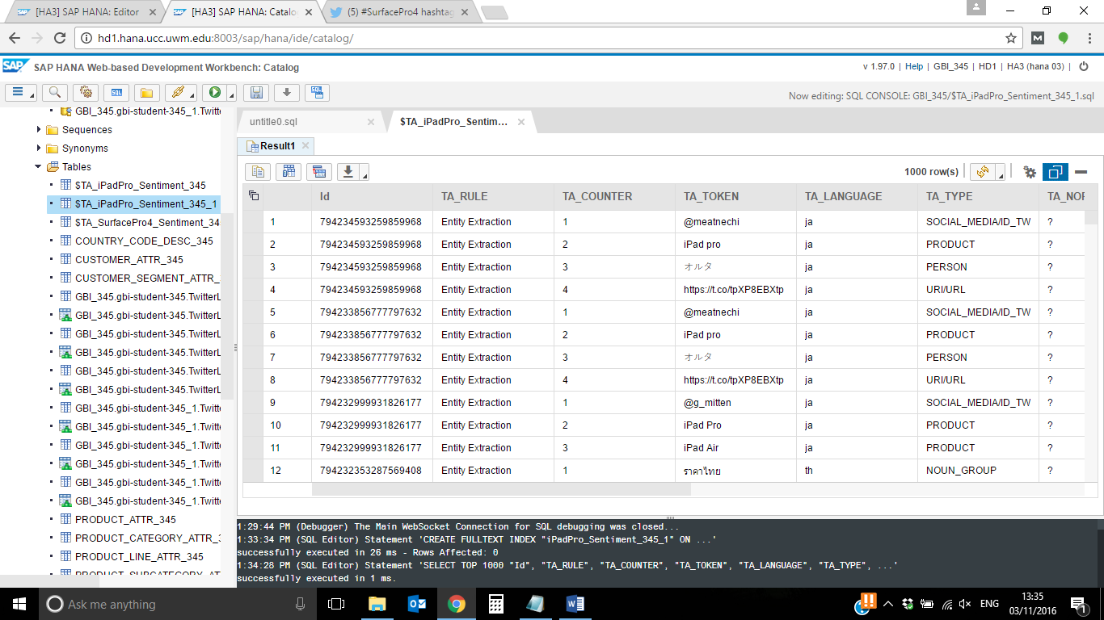

Surface pro-

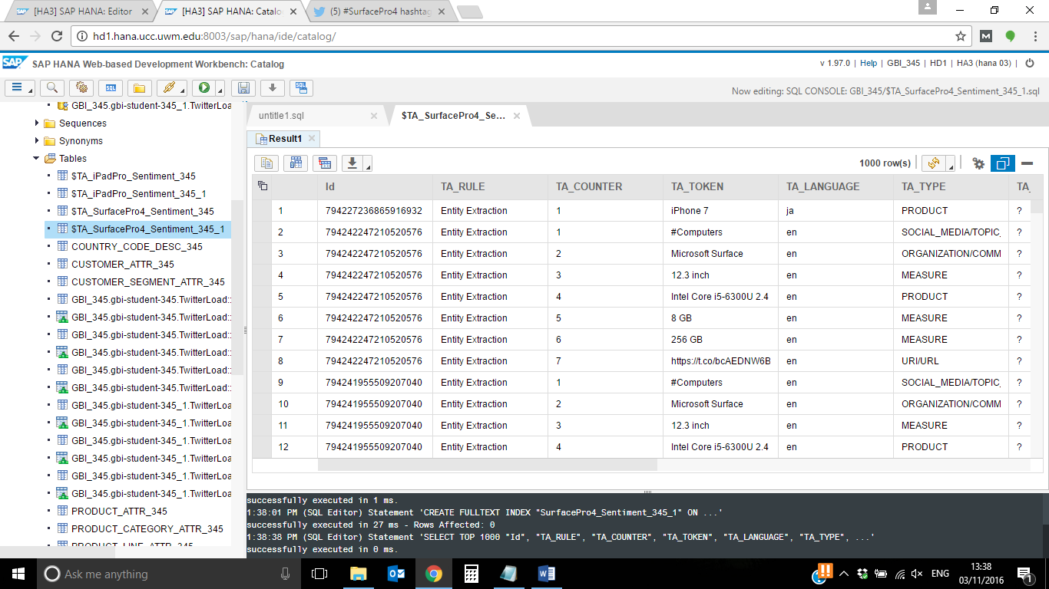

If you have a deeper look into the data, you will recognize that the term “Pro” is sometimes recognized as a weak positive sentiment. Actually this is not a sentiment, but the second word of the term “iPad Pro”.

That means we have to find a way how to tell the SAP HANA database, that “iPad Pro” is the name of a product.

Now, repeat the aforementioned steps to create a Fulltext index for **Surface Pro 4.**

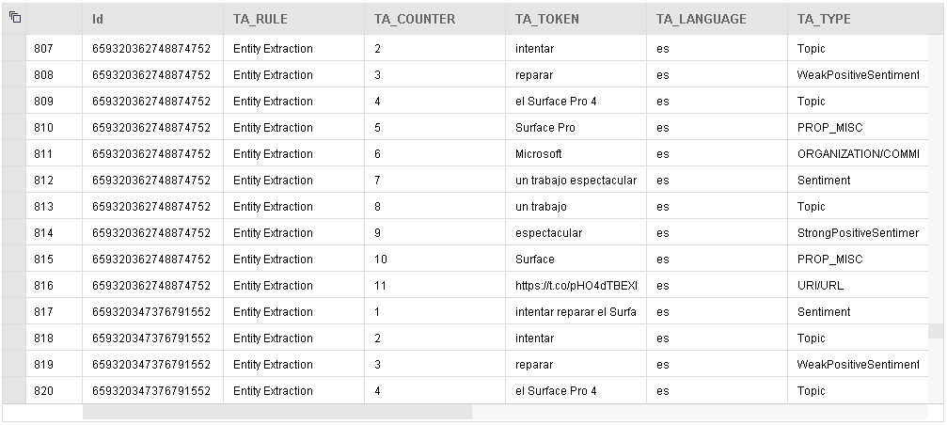

**Paste your screenshot here**

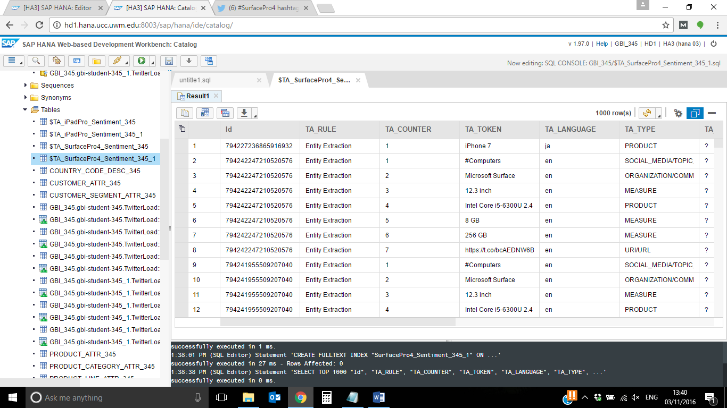

If you carefully study the data, you will recognize that the term “Surface Pro” or “Surface Pro 4” is recognized as a topic but should be recognized as a product.

That means we have to find a way how to tell the SAP HANA database, that “Surface Pro 4” is the name of a product.

**Custom Dictionary**

The iPad Pro and the Surface Pro 4 are not reliably identified as products. We have to find a solution for that problem. We can resolve that issue by adding a custom dictionary for unknown terms in the SAP HANA system.

Open the Editor of your system in a browser using the Web IDE.

<http://hd1.hana.ucc.uwm.edu:8003/sap/hana/ide/editor/>

To create a custom dictionary, you need a folder to store all necessary configuration files.

Right click on your package “gbi-student-###” and create a new package with the name “CustomDictionaries”.

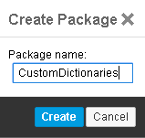

Now right click on the new package and choose

New ► File

As a file extension for custom dictionaries, you generally enter “.hdbtextdict”. Furthermore, a convention is to add the language of the dictionary in the beginning of the file name, separated by a hyphen. If you don’t add any language, the file will be used for all languages. First we want to create a custom dictionary for the iPad Pad. Name the file “iPadPro_###.hdbtextdict”.

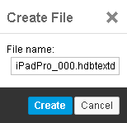

The editor for the file will open. Copy the following code and paste it into the editor:

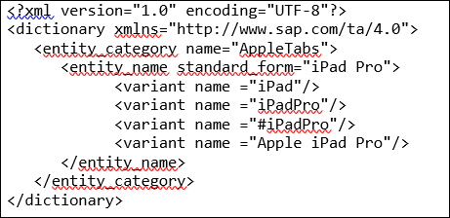

Save the file. It will be saved and activated on the server.

**Paste a screenshot of your dictionary along with the status message.**

Ipadpro-

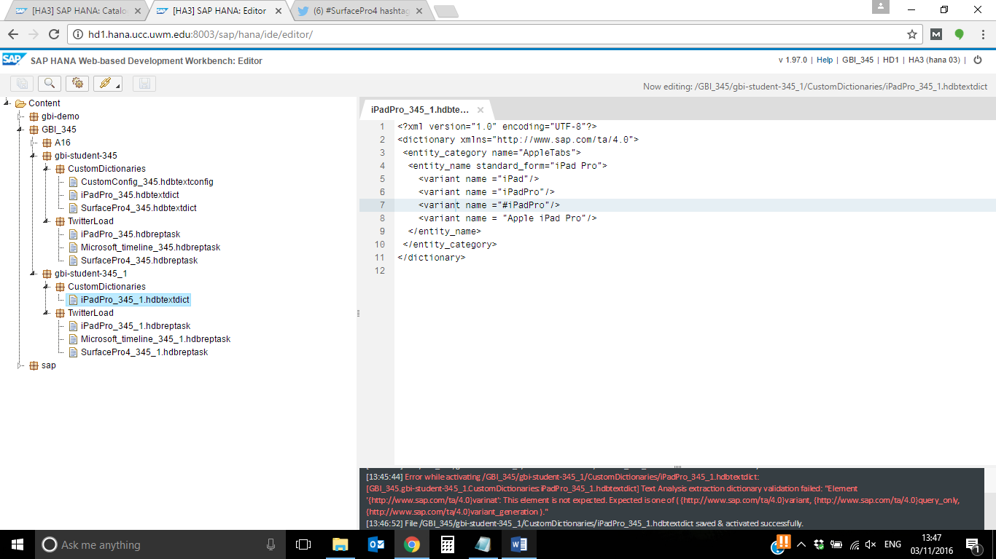

Surface pro-

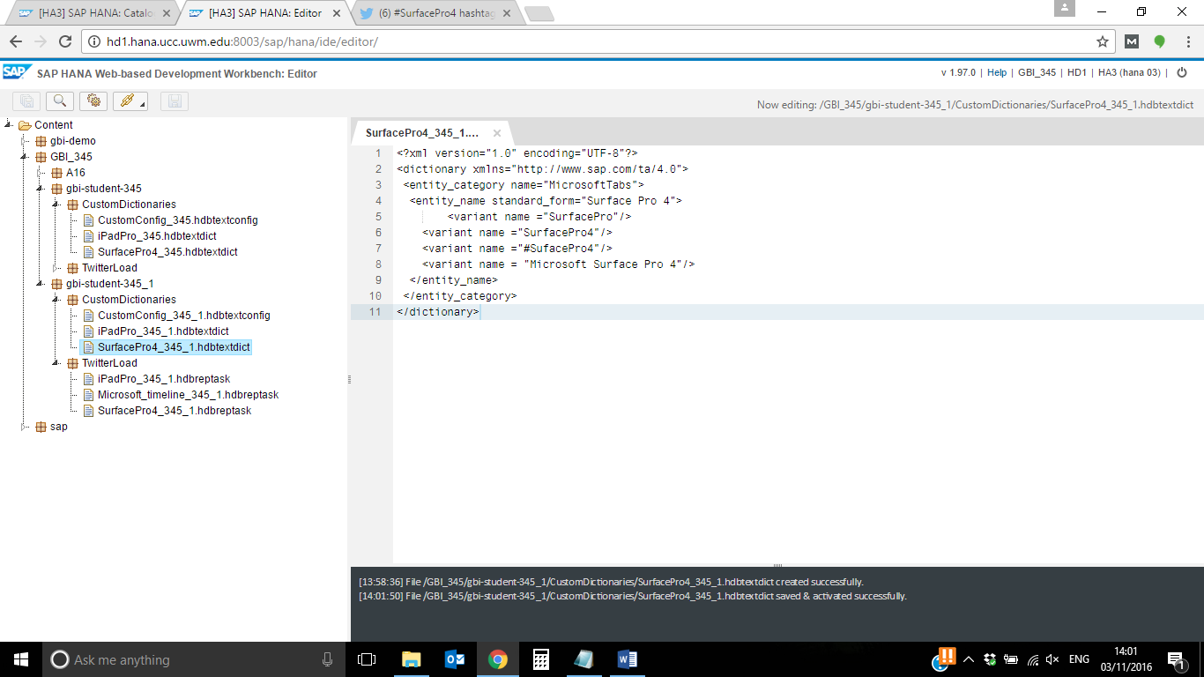

The next step is to create a configuration file for the analysis. The easiest way to do this is to copy a pre-delivered configuration. All configuration files that are pre-delivered when installing a SAP HANA system are stored under:

Content ► sap ► hana ► ta ► config

As we want to implement Sentiment Analysis, we choose the configuration file “EXTRACTION_CORE_VOICEOFCUSTOMER.hdbtextconfig”. Right click on this file and choose Copy.

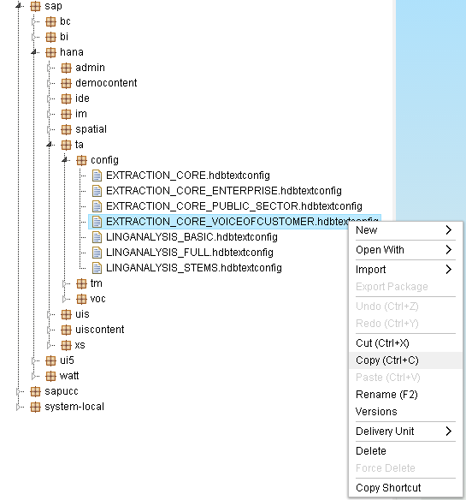

Right click on your package “CustomDictionaries” and click on Paste.

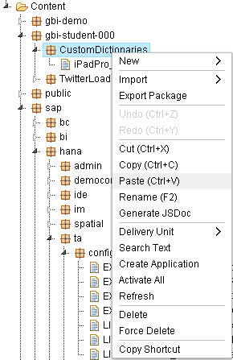

Now you have a copy of the configuration file to which you can add your custom dictionary, but first we want to give the new file a sensible name.

Right click on the file “EXTRACTION_CORE_VOICEOFCUSTOMER.hdbtextconfig” and choose Rename.

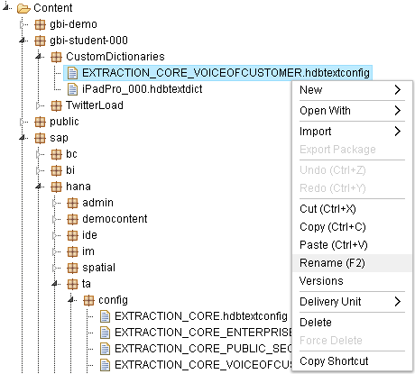

As we want to use the configuration for both analysis, name it “CustomConfig_###.hdbtextconfig”.

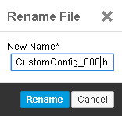

Open this file and scroll down to the line with the dictionaries (that should be around line 138).

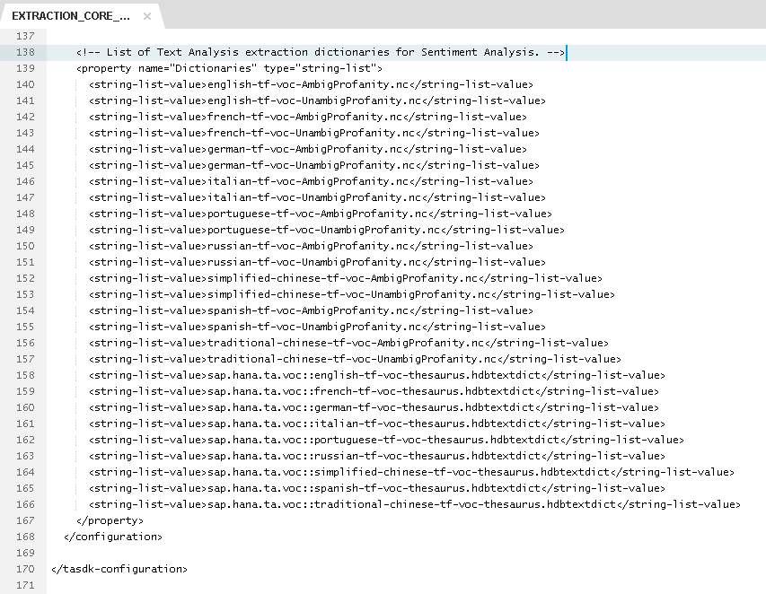

Now, copy and paste the following code above the line “</property>”:

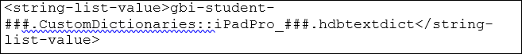

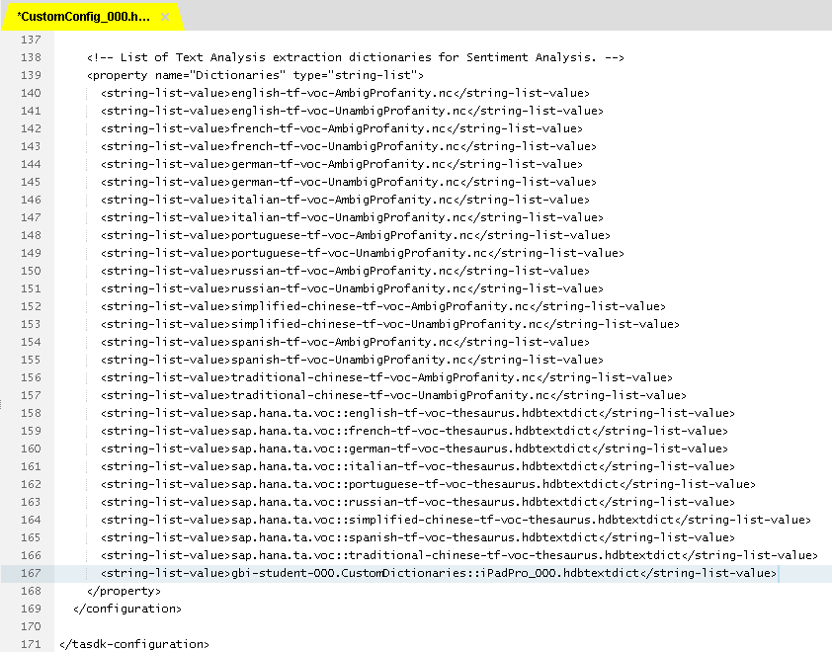

This adds your custom dictionary to the configuration. Save the file.

**What is the status message?**

[13:53:21] File /GBI_345/gbi-student-345_1/CustomDictionaries/CustomConfig_345_1.hdbtextconfig saved & activated successfully.

Now, repeat the aforementioned steps to create a custom dictionary for Surface Pro 4.

Save the file. It will be checked for any syntax errors and afterwards it will be activated on the SAP HANA system.



**Paste the screenshot of your configuration file along with the status message.**

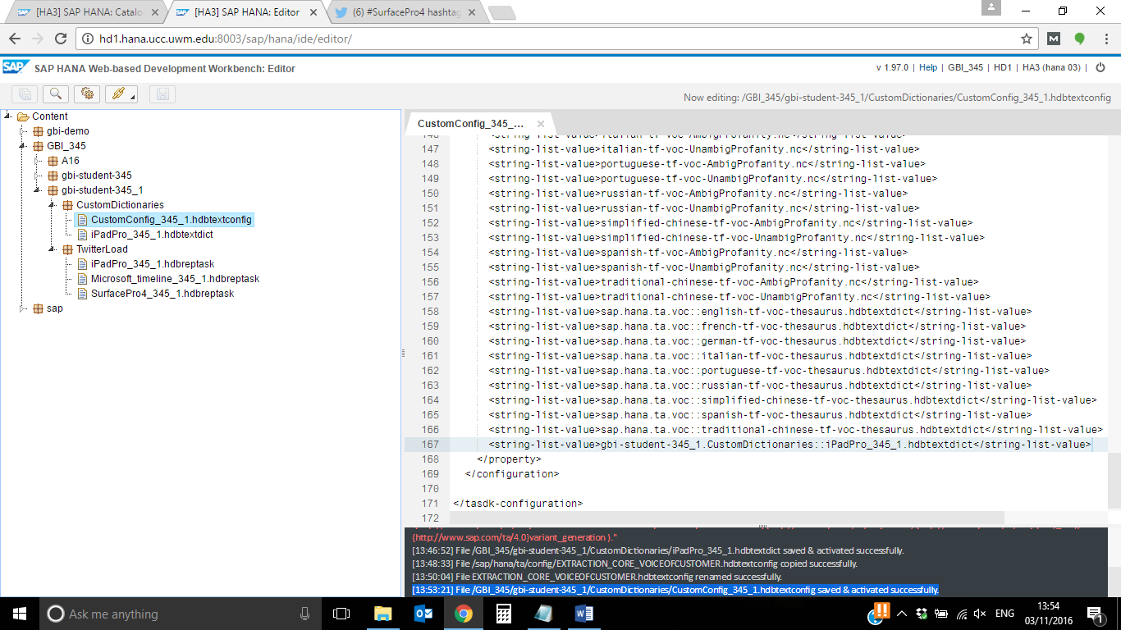

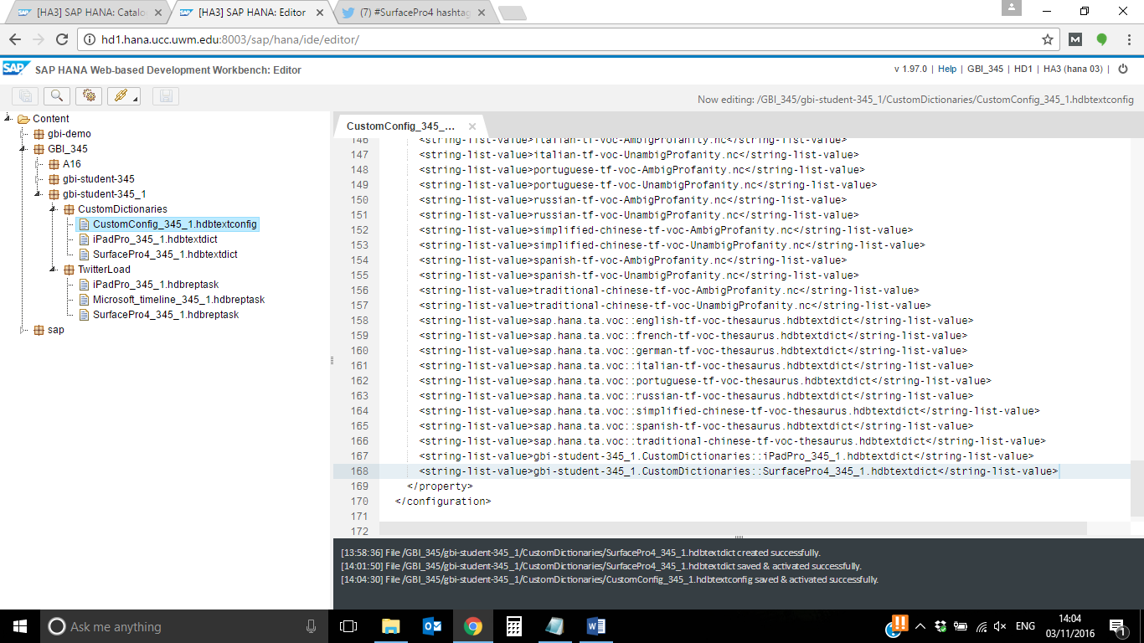

Now you can use the configuration file to do an improved analysis on your twitter data.

To create the tables “$TA_iPadPro_Sentiment_###” and “$TA_SurfacePro4_Sentiment_###” you have to drop the fulltext index on the original tables first. To do this, go to the Catalog in the WebIDE of your SAP HANA system:

<http://hd1.hana.ucc.uwm.edu:8003/sap/hana/ide/catalog/>

Open a SQL console and execute the following statements. Make sure to replace ### with your student id.

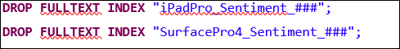

Then recreate the fulltext indexes with the following statements:

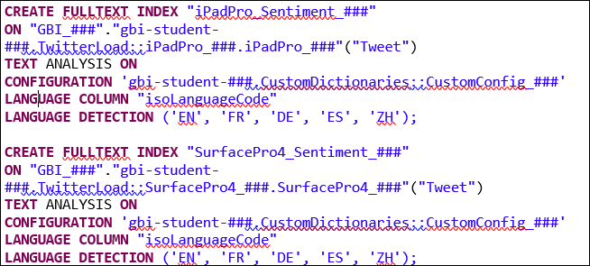

**Paste your screenshot here.**

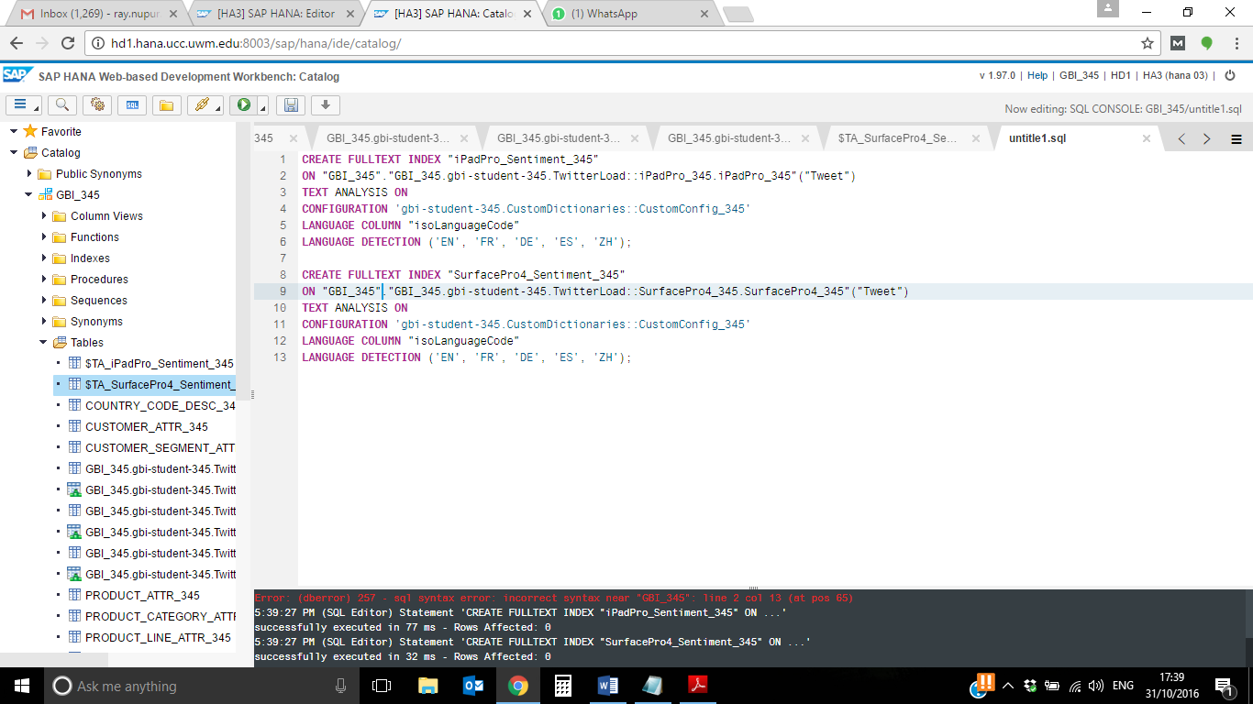

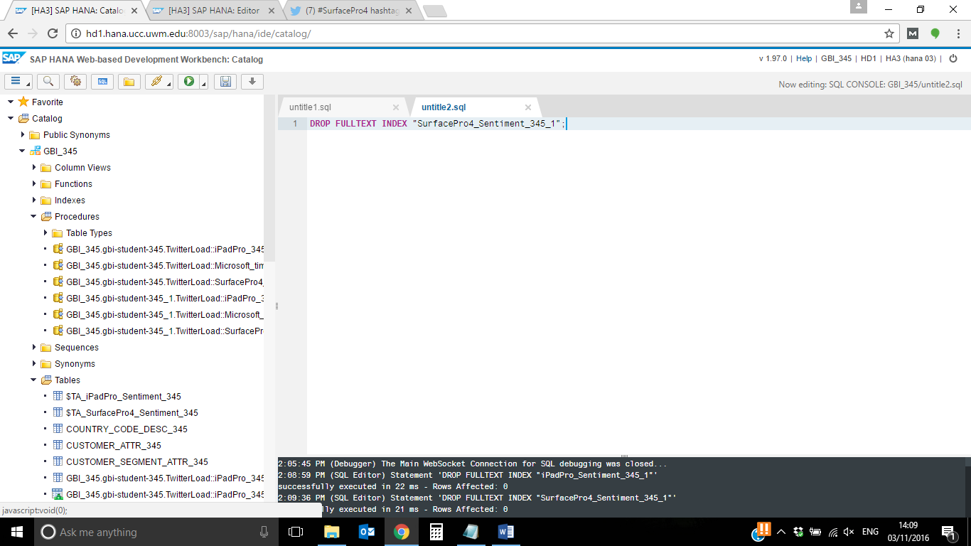

**Full text index**

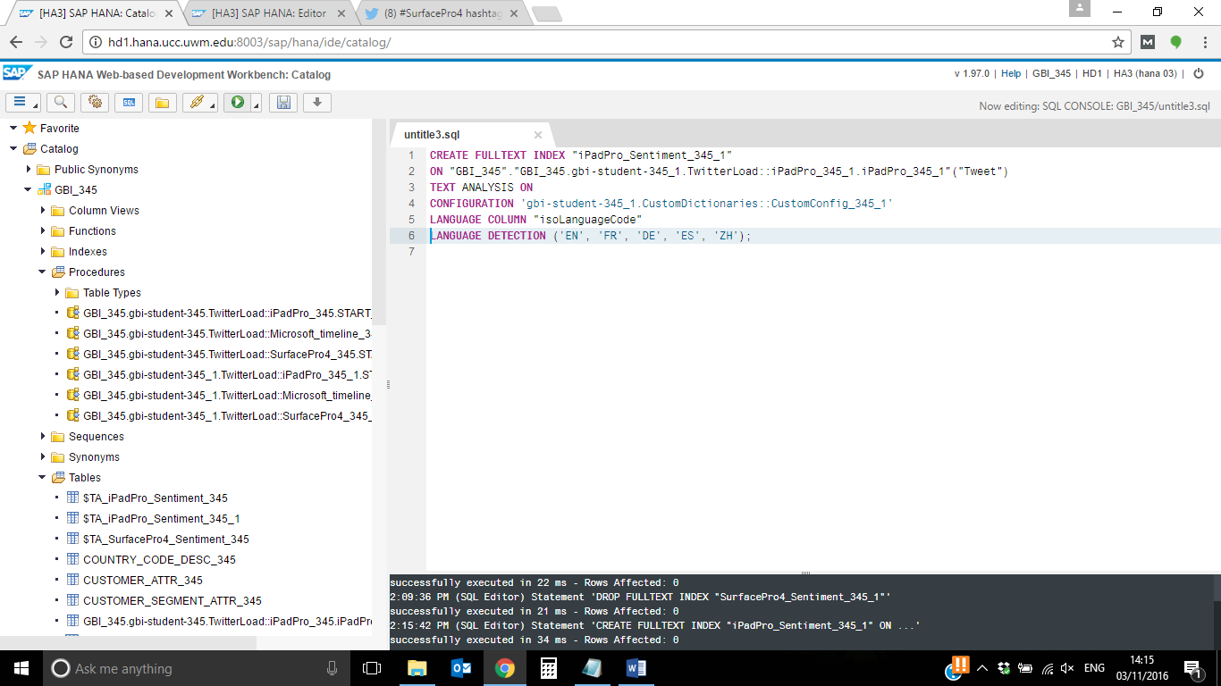

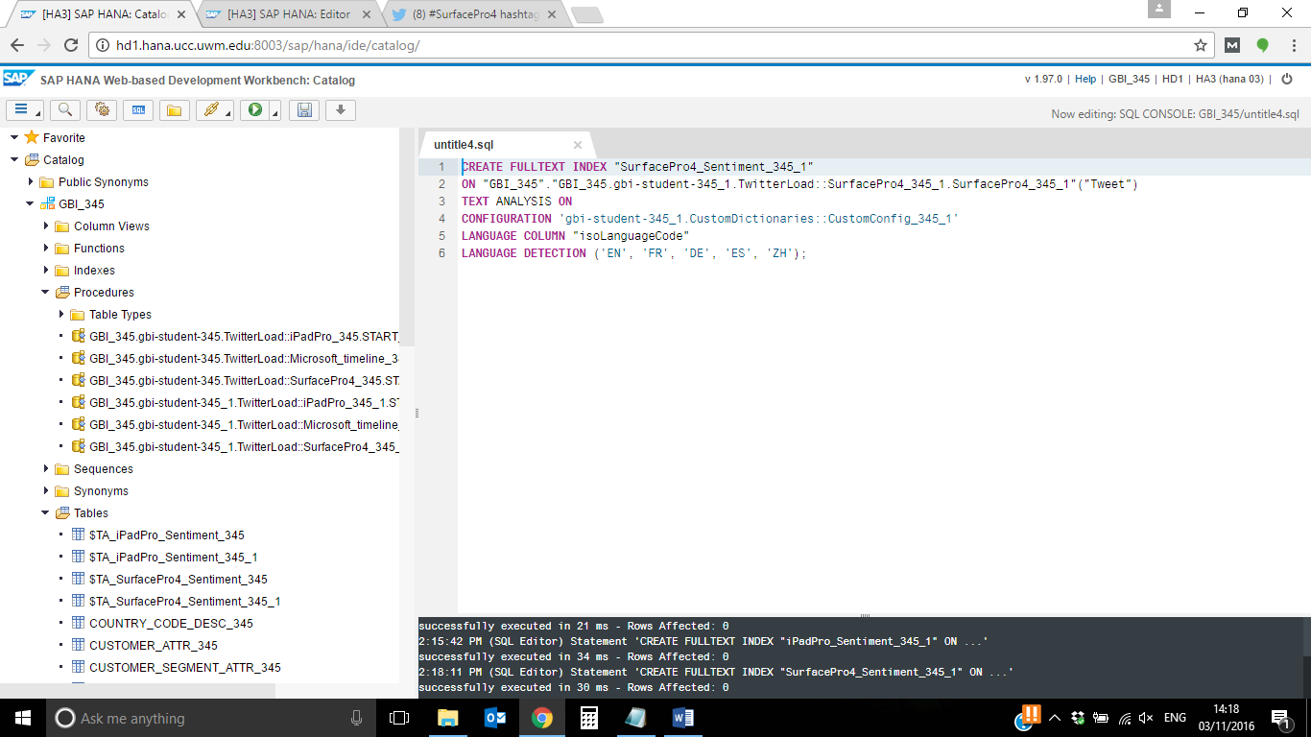

**Data Cleaning**

Delete terms from the result tables that are recognized as a sentiment, but are, in fact, a part of a product. These terms can, for example, contains the following expressions: “Pro:”,   
“Pro –“ or “Pro –“.

Now the sentiments have been analyzed by the search engine. If you have a deeper look into the tables “$TA_iPadPro_Sentiment_###” and “$TA_iPadPro_Sentiment_###”, you will recognize that the term “Pro” followed by signs like “-“ or “:” is still categorized as “asSentiment”. That is why we need to do some data cleansing to filter out wrong sentiments.

Open the Catalog of your system in a browser using the Web IDE.

<http://hd1.hana.ucc.uwm.edu:8003/sap/hana/ide/catalog/>

Go to Catalog ► GBI_000 ► Tables

and right click on the table “$TA_iPadPro_Sentiment_###”. Choose **Open Content**.

Screenshot:

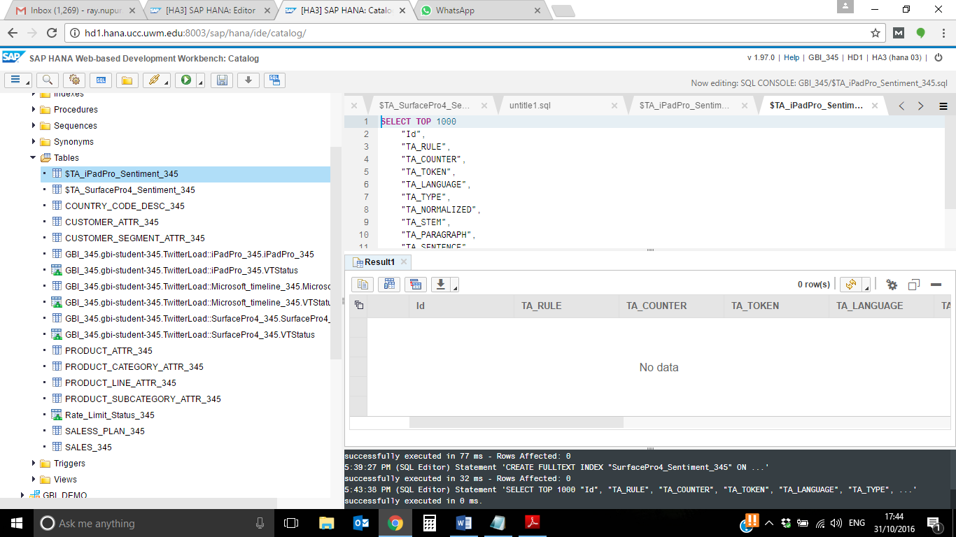

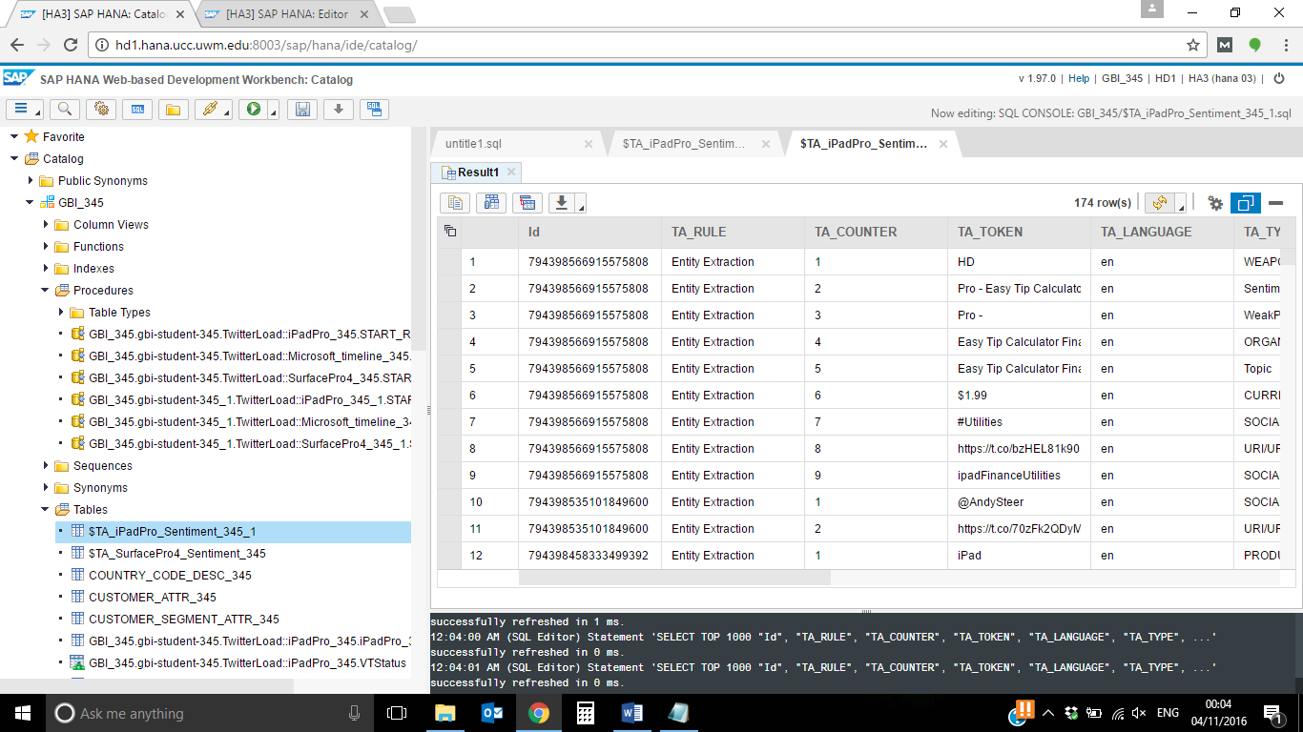

Surface pro:

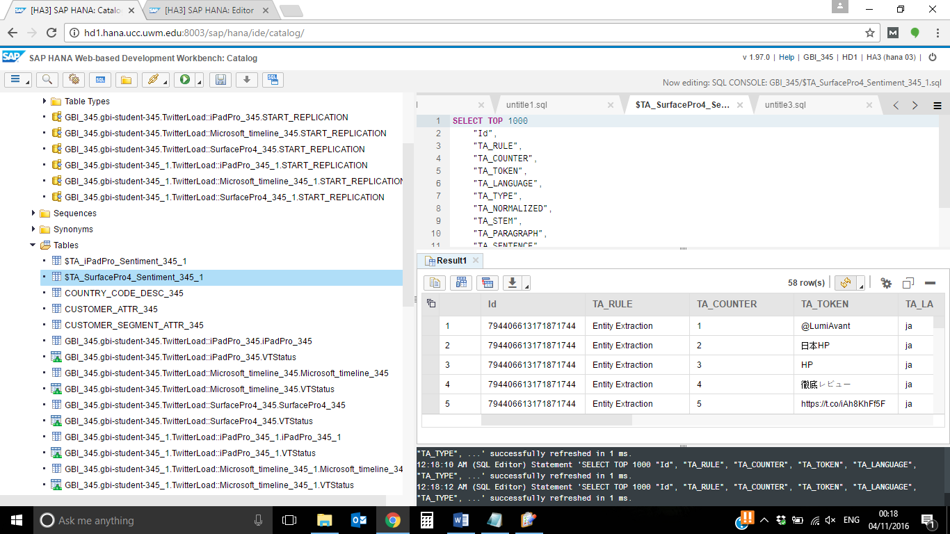

Click on the column “TA_TOKEN” and enter “Pro -” into the filter field. Press Enter.

**Hint: You can also use “Pro:”, “Pro –“ or other terms for the filter. Depending on the Tweets you loaded into the database, you get different results during the sentiment analysis. It may be possible that none of Tweets contains a wrong categorized sentiment and your result list for the filters are empty.**

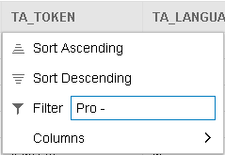

As you can see there are some rows including the TA_TOKEN “Pro -“ but they are categorized as a weak positive sentiment or just as a sentiment. In the next step, we want to delete these rows and clean the data.

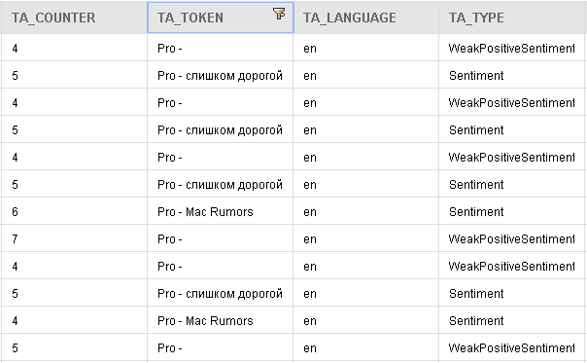

Open a SQL console and copy and paste the following statement. Make sure to replace ### with your student id.

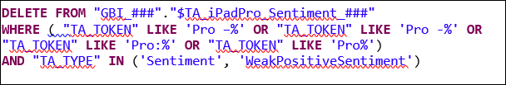

If you now refresh the content view in the WebIDE, you will receive the information that there are no rows in the table containing the term “Pro –“.

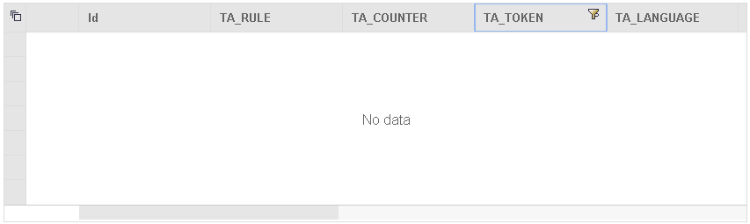

**Paste your screenshot here.**

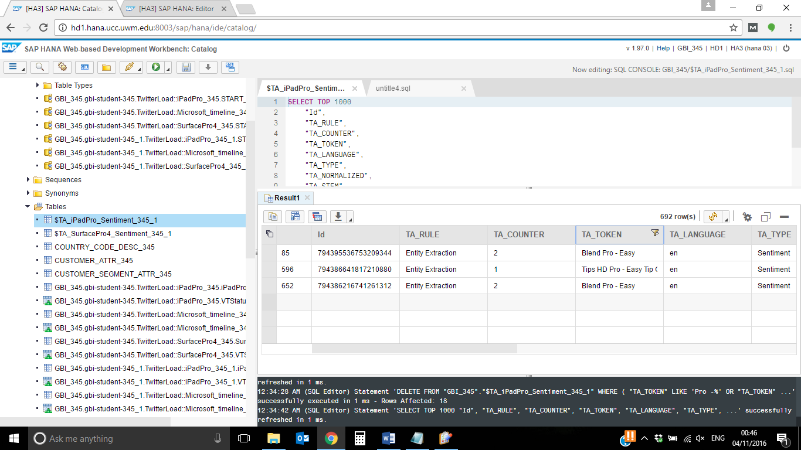

Go to

Catalog ► GBI_000 ► Tables

and right click on the table “$TA_SurfacePro4_Sentiment_###”. Choose Open Content.

Click on the column “TA_TOKEN” and enter “Pro” into the filter field. Press Enter.

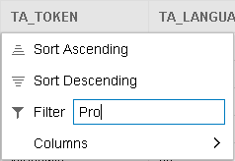

As you can see there are again some rows including the TA_TOKEN “Pro“ but they are categorized as a weak positive sentiment or just as a sentiment. In the next step, we want to delete these rows and clean the data.

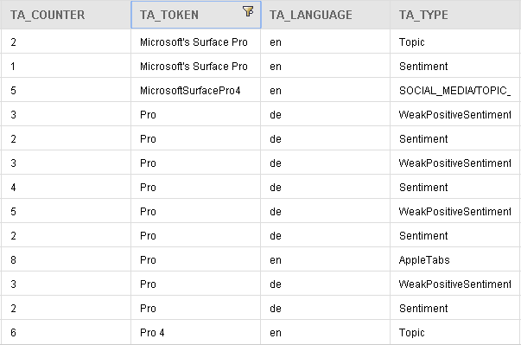

Open a SQL console and copy and paste the following statement. Make sure to replace ### with your student id.

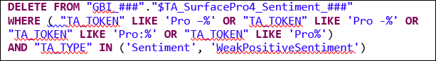

If you now refresh the content view in the WebIDE, you will receive the information that there are no rows in the table containing the term “Pro“.



**Paste your screenshot here.**

